Frameworks for Multi-cell Aware Multiscale Integration
Goals, Philosophy, Tools and Languages
James Sluka, James A. Glazier, Maciej Swat

Scope
The goals of this whitepaper are: 1) To present key concepts of multiscale biological modeling. 2) To present a language hierarchy and tool Framework for (1) that clarifies the work-flow for multiscale model and simulation development. 3) To describe how (2) supports model sharing, integration and model transport among modeling and simulation methodologies. 4) To identify key enabling components missing from current model representations, especially with reference to multiscale, multi-cell models and simulations. 4) To enable the treatment of repositories of models and results as mineable data. This whitepaper will specifically not discuss particular simulation methodologies or applied-mathematics techniques for parameter propagation, coarse graining, etc. It will argue that the use and support of intermediate layers of model abstraction is essential to the goals of MSM, model sharing, mining, validation and reuse.

Framework Goals

This whitepaper will discuss the requirements and philosophy for an Integration Framework which will enable the efficient generation, reuse and support of complex multiscale biological models and associated simulations. We will generally assume that these models include the multi-cell level, I.e. that they represent many individual cells or small cell clusters explicitly in space, roughly corresponding to what is seen through a 20 × microscope objective. However, the generic concepts and goals apply to a much broader spectrum of modeling scales.
To support multiscale model development, integration and curation, any Integration Framework must support the following requirements:
- Models as searchable data: Models should exist in representations which allow searching using standard web tools, allowing the assembly of models composed of multiple submodels without recourse to formal repositories and facilitating the creation, curation and use of repositories.
- (Experimental) data as model: The Framework should allow annotated (experimental) data to draw on repositories to auto generate instantiable models with minimal additional intervention.
- Future proofing using multiple layers of abstraction: Because both computational resources, solver methods and the applied mathematics used to describe specific mathematical approaches are constantly evolving, the Framework must provide primary levels of model description abstraction which provide the ability to specify models (at any spatial level) in a way that insulates the model description of the underlying biology from any data related to the specific methodology used to solve the corresponding simulation. E.g. a model describing a set of genetic, regulatory or metabolic pathways should be solvable using ODEs, Gillespie or other methodologies; a model of tissue development should be solvable using GGH, Finite Element, Center-Model or Vertex Model methodologies; switching from single processor to multi-core, GPU or cluster computation.
- Plugability: The Framework should allow users to combine multiple models at the same or different spatial scales to create larger models without excessive demands for user input. This ability allows the creation of repositories of reusable components which can be modified and extended. E.g. the assembly of a signaling pathway model with a cell-cycle regulation pathway model; the assembly of a cell-cycle pathway model with a model of tumor growth at the multi-cell scale and a tissue-scale model of nutrient supply.
- Encapsulation: The Framework should allow the user to package any combination of models into an encapsulated model, e.g. the definition of a set of pathways models and cell behavior models into a model of a cell type; or the assembly of multiple cell types into a model of a tissue or organ.
- Templating and Reusability: The Framework should allow the user to replace model or submodel parameters without changing the structure of a model, e.g. replacing the parameters in a human hepatocyte cell model with those appropriate for a rat to create a rat hepatocyte model.
- Refinement: Any parameter or coarse-grained concept should be replaceable with a model generating that parameter or concept from data at a finer level of detail. Refinement and Encapsulation are essential to create multiscale models which can serve as ‘adjustable zoom’ microscopes.
- Consistent treatment of experimental and simulation data: The Framework should use identical approaches to describe simulation and experimental data to allow the user to annotate both simulation output and experimental data so they can be compared quantitatively and qualitatively.
- Traceability: The Framework should allow, and preferably automatically, annotate the model to facilitate data archiving, searching, mining and versioning.
- Naturalness: The descriptors used at each modeling level should, as much as possible, correspond to the natural concepts at that level. I.e. the language for specifying Biological Models should correspond closely to standard biological concepts, while languages used for specifying Computational Models should correspond to software engineering concepts. The Framework should make these transitions of concept grouping automatic when translating between levels of abstraction.
- Simplification: The Framework should encourage users to develop models at the highest possible level of abstraction to encourage reusability, mineability and Future proofing.
Together these requirements will greatly facilitate the broader aims of the MSM Framework and the absence of any of them is likely to seriously impede these goals.

Definitions
Terminology in the area of modeling Frameworks is abstruse, inconsistent and confusing. A few definitions of how we will use important terms may help:
Ontologies are lists of terms, their definitions and relationships. They include both non-instantiable categorical ontologies (like FMA and GO) and instantiable ontologies that we use to describe a model or part of a model (like FMA or a markup language).
Languages include both mark-up type descriptions (which have a lot in common with ontologies as noted above) and the “native” Languages of particular simulation environments. In this document, “Language” does not generally refer to a particular programing language, such as C++ or Python, but instead refers to a suite of computational objects that represent the concepts to be modeled or the capabilities of a particular simulation environment.
Tools are programs or subprograms that allow manipulation of models and language components and/or instantiate their concepts. Tools align with the appropriate Ontologies at particular levels of abstraction.
(Computational) Modality refers to the details of a particular computational instantiation. For example, a state machine versus a system of ODEs.
Use Cases are “proof of concept” models. They describe the domain to which a set of Languages, Tools and modealities apply. Use Cases specify the scope of the model and the types of questions the linked simulations can answer.
A Toolkit is an ensemble of ontologies, languages and tools relevant to a modeling and simulation domain.
A Framework is an ensemble of ontologies, languages and tools (a Toolkit) plus appropriate Use Cases relevant to a modeling and simulation domain.
Multi-cell models and simulations span the size domain from single cells to tissues. A Multi-cell model can have varying levels of sub-cellular detail; the exact level of detail depends on the behaviors that the individual cells (or set of cells) must exhibit.
Model is a generic term which can apply to nearly any concept or observation in science. It may refer to a computational model, to an experimentally observable property or behavior, or to a conceptual model that rationalizes an observable process or property.
A Submodel is a model used as a component of a larger or more comprehensive model.
A Biological Model is a formal description of a biological process in a human readable controlled language based on an Ontology, stopping where the qualitative description becomes quantitative.
A Quantitative Model (we lack a natural term for this level of modeling) is a model which provides a minimal unambiguous template for quantitative specification but may lack specific parameter values. The natural bases for such models are “Interchange Languages”.
A Computational Model refers to the mathematical form(s) and classes of algorithms used to describe a particular process or interaction. A Computational Model is a calculable, at least theoretically, representation of a Biological Model. The natural bases for such models are APIs.
A Simulation is the specific code that implements a particular Computational Model. A Simulation is a computable representation of a Computational Model. The natural bases for such models are programming languages (Python, C++, Matlab, Mathematica…).
An Interchange Language(s) provide the mapping between the ontological descriptions at various levels in the model hierarchy.
APIs (Application Programming Interfaces) describe in the input requirements and the output format of computational code designed to carry out various computational steps within a particular modality.

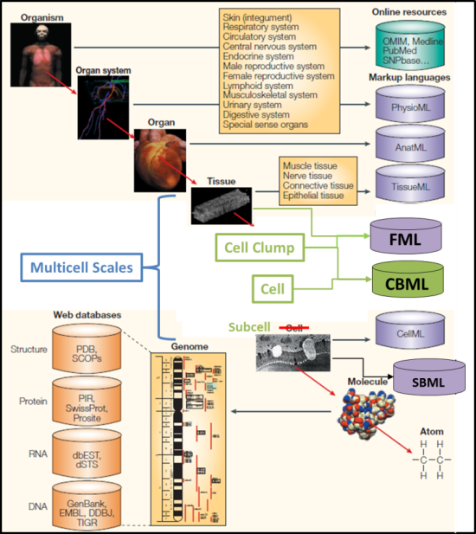
Introduction
Figure 1: Biological scales and the corresponding computational tools and ontologies. (After P. Hunter & T. Borg, Nature Reviews Molecular Cell Biology 4, 237-243 (2003).) Elements added to show the missing scales are shown in green and blue.
Developmental biology, tissue engineering, regenerative biology, cancer biology and other biological fields are becoming quantitative experimental sciences. In many cases such research shares a focus on multi-cellular phenomena (i.e., associations of cells, ECM and organ systems). As time-lapse imaging of 3D protein localization at cell and subcell level becomes more common, researchers face a new type of data deluge. This new flood of data is beginning to provide foundational information on the behavior of cells and tissues, but biologists will still need to develop tools to describe, understand and control the processes underlying their observations. The increasing quantitative content of experiments has enabled the development of reliable computational models of biological and chemical processes at selected spatial and temporal scales (see Figure 1). Figure 1 adapts the Physiome framework to indicate scales missing from the initial Physiome concept and their corresponding modeling languages.
As computational biology tools have evolved there is a growing need to be able to integrate models at different scales with finer models operating at single scales (Figure 2). Improving techniques for simulating subcell (molecular), cell, multi-cell and organ-level processes and combining those models into a robust and scientifically useful tool require concerted effort by many researchers. Large-scale simulation of complex, multiscale biological systems integrates a broad span of investigator expertise ranging from medicine to biology to computational biology to computer and knowledge sciences. Because of the lack of a common (unified) framework current practice requires an early commitment to particular modeling modalities and the generation of platform-dependent code bases. Locating, reusing, recombining, and adapting legacy models require arduous hand-coding methods and considerable expertise in multiple modeling platforms.

What is a Model?
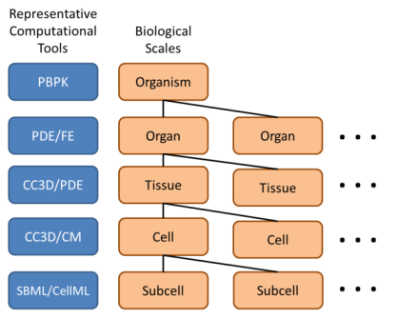
At some level, all of science is “models”. In the biological domain, models range from simplified “blob” diagrams that might be found in a freshman biology textbook, to complex interaction maps such as a KEGG pathway, to more complex representations such as the electro physiochemical models of the heart. Importantly, biological experiments and experimental results are also models. Indeed it is the wet-lab “models” upon which most computational models are not only based upon but also validated against (Figure 3).
Figure 2: Representative Computational methodologies for various biological scales.
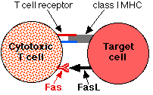
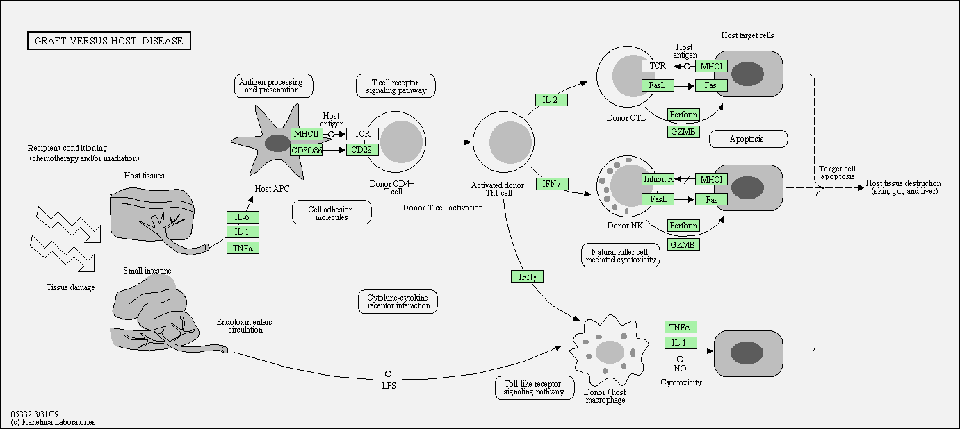
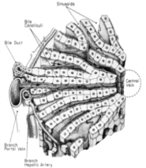
In order to effectively describe a computational biology model it must be possible to describe it first in purely biological terms. At the biological level the model (or module) is guaranteed to be “mineable”, shareable and “hot-swappable” with other models (or modules). In addition, it is the biological description that defines how models at different spatial (or temporal) scales interact.
Figure 3: Biological Models; “Blob” (TL), tissue cartoon (TR), KEGG pathway (C) and high throughput screen (B).
People often use the terms “model” and “simulation” interchangeably. We will refer to specific code executable by a simulation environment and its internal represen–tation during execution as simulations.

Current State of Model Description
Before we can effectively integrate multi-scale models, or indeed before we can adequately describe a single-scale model, we must have an agreed upon framework with which to describe the underlying biology. Without a unified biological description technology, the goal of multi-scale modeling, model (and module) sharing and reuse will be greatly inhibited.
It seems to us that what is first needed is a definition of the modular components at the biological level. This “Biological Description” is agnostic to the details of any particular computational framework. The Biological Description is both the first level of model description and is also the first level of model validation. The Biological Description should be in the language of modern biology and may contain little, or even no, mathematical details, let alone computational instantiation details.
The Biological Model description level is the natural level for model searching, sharing and reuse and for linking of models across multiple scales. Since the Biological Model is agnostic to computational details the details of implementation of a particular module are less of an obstacle to the task of combining (or reusing) models.
Figure 4: Representative ad hoc ontological
description of a computational biology model. Only about one half of the full table is shown here.
We believe that this Biological Model, in a form that a wet-lab biologist would be comfortable with, is a required precondition to effectively developing interoperable multiscale models.
Computational biologists already often use an ad hoc ontological description of their models. Computational biology publications often include a table similar to Figure 5 (Shirinifard 2009). The table in Figure 4 represents an “ontological description” of the particular model but it was created without an actual ontology (since a suitable ontology does not exist). The ad hoc nature of this common publication technique makes locating, interpreting, validating and sharing the model extremely difficult.
The ad hoc nature of the “ontological description” also tends to obscure the choices that were made in translating the Biological Model into a computational model. Details, such as the representation of space and time in the computational instantiation, are not included in the “ontological description” but instead must be culled from the text of the paper or worse yet, from references within references in the paper.
Therefore we believe that before any significant progress can be made in multi-scale modeling and model (module) sharing, reuse and validation there must first be a useable formal ontology that can, at least, describe the observed biology and the types of models that a wet-lab biologist is familiar with. This formal ontology should, at some level, be completely agnostic to both the mathematical description of the system and to the computational framework(s) in which it might be instantiated.

Shareable Model Definition Workflow
To develop a simulation of a biological phenomenon in a shareable fashion, we begin with a qualitative verbal description, a “Biological Model”, described using suitable reference ontologies, and eventually transform it into a script that a simulation environment can execute (Figure 5). At the top, we start with a biological model, as it might be described by a wet-lab biologist, or biology textbook. This level might include genes, proteins, behaviors, cells, tissues and interactions. Existing ontologies (such as FMA and GO) act as “naming authorities” that link objects and concepts to other resources. The ontologies guarantee the “mineability” of the model descriptions and should provide linkages to existing descriptions of concepts and entities included in the particular process being modeled.
Shareable Model Development Workflow
Typical Current NonShareable Model Development Workflow
Figure 5. Shareable (Left) and NonShareable (Right) Model Development Workflows. Most current modeling environments encourage non-shareable model development and most model developers follow a non-shareable work flow.

To produce a well-defined instantiation of the biological model, we must generate a mathematic model which provides quantitative meaning to the biological concepts.
The third level converts the mathematical model into a computational model. In this conversion approximations may be introduced (for example Michaelis-Menten enzyme kinetics) and the model’s granularity (in space and time) is set. Decisions are also made as to how continuous functions in the mathematical model will be converted into computable functions, how boundaries and systemic quantities will be handled, and the various computational methodologies and solvers that will be employed.
The final step is the conversion of the computational model into simulation code suitable to be run in a particular simulation environment.
Many simulation environments (and human model developers) jump directly from the Biological Model to the Simulation (Computational Model), but doing so mixes specific simulation methodologies with the biological and mathematical concepts of the model, destroying portability and obscuring important details and design choices. It also makes the utility of the biological model depend on the particular methodologies employed, so that development of novel simulation methodologies or computer architectures obsoletes the entire model. To maintain portability and futureproof the biological content of models against changes in hardware and software, we must separate the process of mathematical disambiguation of initial biological models from the translation of the quantitative description into a script for a specific computational modality.
To ensure transparency, mineability and shareability the Biological Model to Simulation Code process should follow a well-defined path and be described (and recorded) in an unambiguous way. To do this requires suitable language and process definition standards.
Abstraction Levels
To support the workflow in Figure 5 requires that model development proceed through well-defined levels of abstraction, as shown to the right, with each level corresponding to specific languages and tools. The abstractions and languages are designed so that movement from more to less abstract model specification also automatically moves language organization from concepts represented using standard biological concepts to concepts organized around standard computational concepts.

General Structure of Language Standards, Tools and Toolkits
Figure 6: The elements of a three-component Toolkit and four-component language standard Framework.
To be useful, a language standard requires a Toolkit with at least three components, the language standard itself, a set of tools for writing, editing, viewing and translating the language, and a set of use-cases to illustrate the language application (Figure 6). If the language is to be logically consistent, and be searchable for model-as-data applications, it also requires a reference ontology. The reference ontology must cover the important biological concepts needed in the use-cases.

The Process of Modeling, Levels of Model Description and Model Description Languages
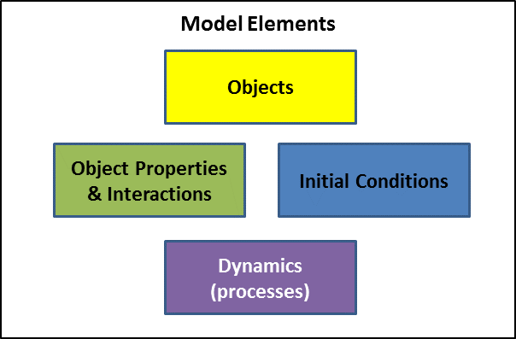
Models and simulations consist of at least four elements; objects, object properties / interactions, initial conditions and dynamics / processes (Figure 7 & 7b). The execution of a simulation produces data, which may or may not have the same form as elements of the model or simulation. The results of a simulation might be a spatial structure which could also serve as an initial condition for another simulation, a kinetic constant which might be a parameter in an object property, or a new object, all of which might be used as input to a new model or to a model at higher or lower spatial scale.
Figure 7: Basic Model Elements

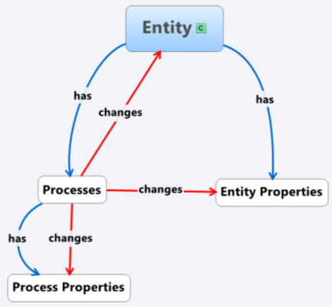
Ultimately, we require languages to describe all of these elements, as well as meta-languages to describe their interactions. However, the number and nature of these languages are not immediately obvious. We can determine these by analyzing the workflow of developing a simulation and the simulation output.
Figure 7b: Ontological Relationships for Model Description.

Simulation Output
If the output data of the simulation are to be sharable and interpretable, they must be represented (or at least representable) using one or more interchange languages (which may not be pure Markup languages, which are verbose for very large data sets). The use of interchange languages to represent data allows simulation results to be compared to experiments, other simulations and to feed back to the higher levels of the modeling allowing model validation and refinement.

It is likely that as some level of detail it will become extremely difficult to completely describethe simulation output since the output may contain levels of complexity not present (or not recognized) in the original Biological Model.Ontologies for Biology
A plethora of biological ontologies have already been developed. These ontologies range from exhaustive “naming authority” type ontologies such as FMA and GO to “toolkit” ontologies like SBML and OPB. The major difference between a “naming authority” and “toolkit” ontology is their ability to be used to instantiate a description of a particular biological system. Ontologies like FMA and GO provide a controlled vocabulary of concepts and generally place those concepts in some type of hierarchical tree. For example, FMA can be used to provide the name “hepatocyte” to the major cell type of the liver. In addition, the FMA trees locate that cell (“is part of” the “portal lobule” which “is part of” the “liver”) and may also provide cell lineage or other information. However, FMA does not provide the terms needed to specify that a model might consist of multiple hepatocytes and those cells have a characteristic geometric distribution. In “naming authority” ontologies a new concept, for example a cell type in FMA or gene in GO, is generally added to the ontology and becomes a permanent component of that ontology.
“Toolkit” type ontologies are designed to provide a set of basic object types and a set of possible relations between those types. For example, to instantiate a hepatocyte in OPB one might describe the size and shape of the cell, its neighbors and the types of processes it can undergo. FMA does not already have a concept of “hepatocyte”, indeed it really doesn’t contain the concept of a cell. Once a cell is described using the terms of OPB the resulting description does not become a permanent part of the ontology.
We believe that MSM (and computational biology modeling in general) requires the creation of a suitable “mash-up” ontology that can be used to describe Biological Models and computation models.
Ontology development is a time consuming task. To develop the complete ontology needed for describing both wet-lab experiments and results and computational models is a daunting task. It may be possible to largely avoid the creation of a large and robust ontology by instead creating, essentially, a markup language and a fairly small ontology. The majority of the ontological terms (and relations) can be “inherited” from existing ontologies. For example, a model (wet-lab or computational) should use the excepted names for tissues, cells, genes and proteins. In a markup-up type description those terms can be extracted (linked to) existing “naming authority” ontologies such as FMA and GO. This implementation has several important advantages. 1) It automatically creates “crawlable” linkages to rich data repositories (not only the referent ontology but to linkages contained therein). 2) It insures that named entities in models use accepted names, which is a requirement for efficient mining of the models. 3) It significantly reduces the work required to develop a useable “model description” ontology. 4) It insures that the basic structure and concepts are “biologically” defined (as opposed to computationally defined).
For concepts relating to spatial, temporal and energy (K, k, ΔG …) terms OPB might be a suitable external ontology that can provide the needed terms and relationships.
The required depth of the “ontology” or mark-up language is unclear to us. It must be able to at least specify observable biology. This would include the ability to describe both objects (small molecules, cells, proteins, organs etc.) but also biological processes like transport, mobility, binding, development, differentiation, growth, death, signal generation and receiving and so forth. It seems likely that the language will also need to be able to describe the fundamental mathematics of a particular process. For example, kinetic and diffusion processes defined mathematically (but in a computationally agnostic way).
As the need to describe the model progresses from the Biological Model to the computational instantiation of the model the types of relationships may explode in number. It seems reasonable though that certain characteristic of the computational instantiation should be describable. For example, how spatiality is treated. Is space discretized or continuous? Does the model even have a concept of space? The same for time, are there time steps (if so how big) or not? How exactly are fundamental biological processes instantiated? If the model includes cells that grow what controls the growth and what formula is used to calculate the growth as a function of time?
Even if it is found that an ontological description of all of the computational details is not practical it is still critically important that the Biological Model is described using the structured language(s) down to at least the API level
Some work has already been done on “mash-up” type ontologies for computational biology. SemSim and SemGen (Univ. Washington) include many of the ideas we have presented here. Extending those tools to describe wet-lab assays and results and enhancing their ability to describe Biological Models would leverage existing software and may provide a rapid route to a functioning ontology and markup language tool. Adding the ability to publish the models via the SW may provide a rapid route to model dissemination, validation, mining and reuse.

Advantages of an “Ontological” description at the Biological Model and other levels
If models (biological, computational …) can be described in a structured way then the models can be published using semantic web (SW) technologies. This method of publication makes the models searchable without a user needing to know where to actually look for the models. The model might be in a well maintained computational model repository (like the BioModels Database), or it might be on a server maintained by an individual research lab. The data might be a Biological Model, or a computational model, or an entry in a vast repository of biological assay results such as the EPA’s ToxCast system. (Which should be describable using our imagined ontology and publishable via the SW, instead of being buried in a web accessible database which cannot be automatically mined.)
An important benefit of our imagined ontology is that experimental data is describable, SW publishable and searchable (mineable). Since that data is often used to parameterize models finding it should become easier.

Defining the Ontology (or markup language)
The ontology perhaps should be developed in two arms. The first arm would be the selection (possibly with certain restrictions) of the reference ontologies. The second arm is the identification of key terms and relationship that are either absent in the reference ontologies or that are of such fundamental import to experimental and computational biology that a redefinition is warranted.
The key terms and relationships could perhaps be defined using two pathways. One pathway would start with wet-biology and biologist. What are the fundamental objects and processes that they think must be included? The second pathway would start with existing computational biology models and work backwards. It is not necessary that the ontology can describe all the details of the computational model but it appears to us that most computational biology groups have already (if unconsciously) followed the first pathway and there modules and code have a tendency to mirror basic biological concepts. Working backwards from exiting computational models leverages that knowledge.

A Really Simple Sample Model and Markup
What exactly would the process look like and what would it create? We will start with the very simple model, like what might be found in a basic biology text book. Shown at the right is the interaction of a Cytotoxic (killer) T-cell with an infected host cell. (From http://users.rcn.com/jkimball.ma.ultranet/BiologyPages/T/Transplants.html)
We start with describing the objects in the model, two cell types and four membrane bound proteins. We can use FMA to describe (unambiguously name) the cells and GO to describe (unambiguously name) the four proteins. We can use terms and relationship from OPB to describe the binding events. In pseudo XML like format;
<XML=”MSM pseudo Code”>
<External “MSM” link to MSM> <!—our imaginary ontology -->
<External “FMA” link to FMA>
<External “CL” link to CL >
<External “GO” link to GO >
<External “OPB” link to OPB>
<Cell type=FMA:"PREFERRED NAME=T-cytotoxic cell" FMA:"FMAID=70573">
<protein location=FMA:" Plasma membrane" name=GO:"T cell receptor">
<protein location=FMA:" Plasma membrane" name=GO:"Fas">
</Cell>
<Cell type= FMA:"PREFERRED NAME=cell" FMA:"FMAID=68646">
<protein location=FMA:"Plasma membrane" name=GO:"Class I MHC">
<protein location=FMA:"Plasma membrane" name=GO:"FasL">
</Cell>
<Interaction type=binding>
<entity1 name=GO:"T cell receptor">
<entity2 name=GO:"Class I MHC">
<FMA:Dissociation Constant="1e-7” Units=”Molar”>
</Interaction>
<Interaction type=binding>
<entity1 name=GO:"Fas">
<entity2 name=GO:"FasL">
<FMA:Dissociation Constant="1e-6” Units=”Molar”>
</Interaction>

The markup above adequately recapitulates the details of this very simple Biological Model. Though simple the model still contains a significant amount of information (“knowledge”). To extend this markup to a particular computational framework might involve including terms to describe how the binding is calculated; mass action law, stochastic etc. A particular computational framework might also need to describe the movement of the cells and that requires some definition of space, distance and time. However, regardless of the markup that is added to describe the computational instantiation of the model the Biological Model, and its description, is constant.
In the above description we have left out the several details of this Biological Model. For example, 1) binding of Fas to FasL trigger apoptosis of the Target (infected) Cell. 2) The T-Cell Receptor (TCR) represents a complex entity that is not describable in the way most genes and gene products are described, therefore the “naming authority” link to FMA does not have the same information content as most gene/gene product names. The mature form of the gene is the result of an irreversible genomic rearrangement that occurs as the T-Cell matures. 3) The TCR – Class I MHC interaction is actually mediated by a peptide fragment present in the Target Cell. 4) “Class I MHC” represents a heterodimeric protein complex.
Besides describing the basic model the markup above provides “crawlable” linkages to other information. For example, following the FMA linkage for FMA:"PREFERRED NAME=T-cytotoxic cell" provides the synonyms for this cell type: “Cytotoxic T-lymphocyte”, “Cytotoxic T cell”, “Killer T lymphocyte”, “Killer T cell” and “Cytotoxic T lymphocyte”. Following the GO linkage for “Class I MHC” leads to gene and protein data such as MW, sequence and tissure distribution.
The sample markup above gives a very simple pseudo-description of the binding interaction. The ontology should also allow more detailed models to be incorporated into the model’s description. As long as there is a systematic way to describe the components, preferably via linkages to existing ontologies, then any markup can be included in the model. For example, an SBML type model could be included to describe the computational modeality for the binding equilibria.

Model Sharing and Reuse
An effective path to preparing a multiscale model would include identifying existing models that contain useable components for the multiscale model. Identification of suitable existing model would be greatly facilitated if those models include biological descriptions created with suitable reference ontologies. In particular, the use of “naming authorities”, such as FMA and GO, insures that the named entities adhere to accepted naming conventions. Misnamed entities in model descriptions effectively become invisible to most search technologies. In addition to providing consistent names, the reference ontologies can provide higher levels of abstraction that will greatly facilitate identification of models that are conceptually identical even though the names of the actual entities are different.
For example, consider the simple two cell model of a Killer T-Cell interaction outlined earlier. If that description was in a searchable database (or SW form) then it could be located with queries such as “T-cytotoxic cell” or “T cell receptor”. In addition, since “T-cytotoxic cell” is not the commonly used name, a semantic web search engine with access to FMA would also be able to locate this model if the user used any of the pseudonyms that FMA provides such as “Cytotoxic T-lymphocyte”, “Cytotoxic T cell”, “Killer T cell” etc.
Besides provide a consistent naming and name resolution mechanism the use of structured reference ontologies also makes it possible to search for models using more general terms. In the above example “T-cytotoxic cell” ISA “cell” and “T cell receptor” ISA “cell membrane bound receptor”. That means that this ontological description, and any associated computational model, would be identified as a generic model of a cell with a membrane bound receptor. In addition, this type of abstraction will easily identify equivalent models implemented in different computational modalities. This high level of abstraction would be expected to greatly facilitate the identification and reuse of model components.

Existing Approaches to Cross scale (and cross modality) Model Descriptions
SemSim (Gennari 2008) is a tool and methodology that facilitates the back mapping of a Simulation Code to appropriate reference ontologies. Once the model is back mapped the terms can then be forward mapped into other code modules. SemSim, and related tools, provide proof of concept studies of the power of using well defined ontologies and mapping tools to combine disparate models.

Needs
Figure9 adapts the Physiome framework to include possible reference ontologies. In addition to existing ontologies, such as FMA and GO, it is likely that additional ontologies will be needed, particular for the various Computational Modalities.
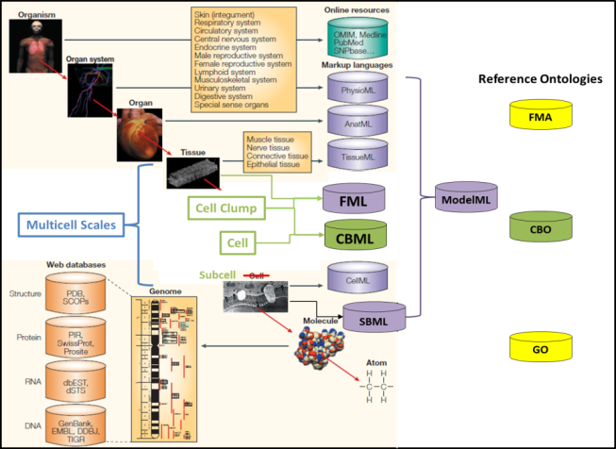
In addition, tools that map from the ontological description to particular computational tools will be needed.
Figure 9: Biological scales and the corresponding computational tools augmented with additional reference ontologies and languages to form a Model Development Framework.
Finally, to actually get users to use this method of model definition a tool is needed that provides immediate tangible benefit to the user. A suitable “carrot” might be a graphical user interface that allows biologists, both wet-lab and computational, to describe their models. The user would immediately benefit from having a high quality graphical description of their model and would also have a searchable (mineable, sharable…) description of their model. The tool could greatly simplify, and hence “enforce”, the use of the appropriate reference ontologies (or markup languages) at all stages of the model building process. A tool that provides both easy markup as well as other immediate tangible results will greatly increase the chances that the markup and ontology tools are widely adopted.

References
- Sauro, H.M., Hucka, M., Finney, A., Wellock, C., Bolouri, H., Doye, J., Kitano, H., (2003) “Next generation simulation tools: the Systems Biology Workbench and BioSPICE integration. OMICS.” Winter; 7(4):355-72.
- Hucka, M. et al., (2003) “The Systems Biology Markup Language (SBML): A Medium for Representation and Exchange of Biochemical Network Models”, Bioinformatics, 9(4):524–531.
- OPB
- FMA
- CellML
- Choi, JY, Davis, M. J., Newman, A. F., Ragan, M. A. (2010) “A Semantic Web Ontology for Small Molecules and Their Biological Targets”, J. Chem. Inf. Model, 50, 732-741.
- Sankar, P., Ahila, G. (2007) “Ontology Aided Modeling of Organic Reaction Mechanisms with Flexible and Fragment Based XML Markup Procedures”, J. Chem. Inf. Model, 47, 1747-1762.
- Shirinifard A, Gens JS, Zaitlen BL, Popławski NJ, Swat M, et al. (2009) “3D Multi-Cell Simulation of Tumor Growth and Angiogenesis”, PLoS ONE 4(10): e7190.
- Gennari, J. H., Neal, M. L., Carlson, B. E., Cook, D. L., (2008), “Integration Of Multi-Scale Biosimulation Models Via Light-Weight Semantics”, Pacific Symposium on Biocomputing 13:414-425. SemSim
- Roux-Rouquie et al., 2005, “Metamodel and Modeling Language: Towards an Unified Modeling Language (UML) Profile for Systems Biology”, SCI05, Orlando, Florida, USA, July 10-13. No representation of space?
- Sun, Zhouyang, PhD Thesis, 2008, “Using Ontology and Semantic Web Services to Support Modeling in Systems Biology”, Centre for Mathematics & Physics in the Life Sciences and Experimental Biology, University College London.

Because of its history, Physiome lacks a concept of a cell as a spatially extended motile (active) agent. Despite its name, CellML actually describes molecular-level chemical and electrical objects and their behaviors. CBML and CBO are respectively, a proposed interchange language and ontology to represent the missing “cells as agents” scale.
Yes, the semantic web is largely vaporware, or at least it is as a general method of coding information on web pages. However, in this case only the pages that our community generates need to conform to the standard.
The style should probably by OWL/RDF instead of nested XML.
In the Biomodel database conversion of uncurated models to curated models often includes corrections in the names of entities like genes and proteins. This process should have been done by the original model builders. Not doing so reduced the validity and usability of their computational model.

