DATA SHARING WORKING GROUP

GOALS and OBJECTIVES

Immediate Objectives

1. Explore the interests of the IMAG community to share data that is necessary for model creation and model verification

2. Discuss the feasibility and acceptability of using PhysioNetWorks as a mechanism for data sharing.

Long Term Objective

1. Provide and support the infrastructure for data sharing

BACKGROUND

A. What do we mean by “data” sharing?

The modeling paradigm might be represented as follows:

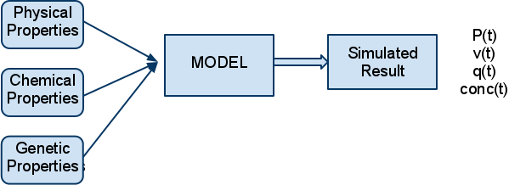

INPUT to models could certainly be considered “data”. For example, a lumped parameter model of the arterial system would need data concerning the dimensions of arteries throughout the circulation, the viscoelastic properties of the arterial wall, the physical properties of the blood, etc. The OUTPUT of the model might be pressure waves, flows, etc. To verify the model it is necessary to compare the model’s simulated results to real physiologic experimental data.

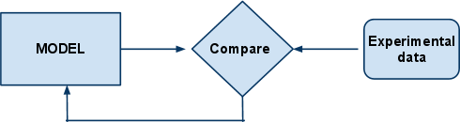

Both “input” data and experimental data are critical to the MSM effort, and ideally both types of data should be shared. The Data Sharing Working Group should address both data types but it might be wise to focus our initial efforts narrowly to increase our chances of success.

Data sharing and model sharing are complementary. Each model should be validated against data, and those data, as well as the models, should be in the public domain. Each addition of data to the database provides an opportunity to test the models further, extending their range of applicability or demonstrating inadequacies that need to be addressed through model refinement or replacement.

Obviously data sharing only makes sense if there is a community of investigators who are working on similar problems, and who see a need for common data. Perhaps the first task for us is to investigate whether the IMAG community actually sees a need for data sharing! And to try to identify the biggest perceived need.

B. How might data sharing be supported?

PhysioNet, and in particular PhysioNetWorks might be a suitable mechanism to support data sharing. ( http://physionet.org ) ( https://physionet.org/users/ )

QUESTIONS FOR DISCUSSION

1. Is there a perceived need and an interest among IMAG investigators to share data?

2. Should sharing be required by funding agencies (or is it already)?

3. How “open” should the sharing be?
Limited to IMAG?
Open to everyone worldwide?
Relatively closed for a fixed period?

4. Data sharing makes most sense within modeling efforts in a similar domain.

Are there subsets of IMAG members who work in similar domains?
How do we identify investigators who are interested in data sharing?

5. Is PhysioNet Works a suitable mechanism to support data sharing within IMAG?

