DATA SHARING WORKING GROUP

Participants:
Grace Peng, Stephanie Sabourin, Susan Gregurick, Peter Lyster, Susan Volman (NIDA), Tim Gondre-Lewis, Yuan Liu, Stephen Marcus, Donna Lochner, German Cavelier, Tom Russell, Alison Deckhut Augustine, Roger Mark, Stephen Eubank, Ahmet Erdemir, Gang Liu, Herbert Sauro, Jim Bassingthwaighte, Jim Sluka, Joy Ku, Madhav Marathe, Maciej Swat, Alexander Popel.

GOALS and OBJECTIVES

Immediate Objectives

1. Explore the interests of the IMAG community to share data that is necessary for model creation and model verification

2. Discuss the feasibility and acceptability of using PhysioNetWorks as a mechanism for data sharing.

Long Term Objective

1. Provide and support the infrastructure for data sharing

BACKGROUND

A. What do we mean by “data” sharing?

The modeling paradigm might be represented as follows:

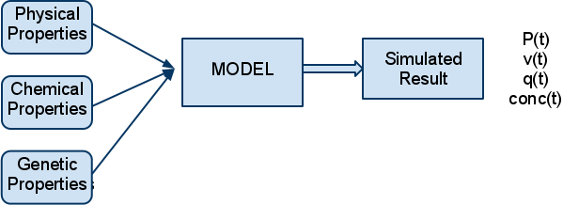

INPUT to models could certainly be considered “data”. For example, a lumped parameter model of the arterial system would need data concerning the dimensions of arteries throughout the circulation, the viscoelastic properties of the arterial wall, the physical properties of the blood, etc. The OUTPUT of the model might be pressure waves, flows, etc. To verify the model it is necessary to compare the model’s simulated results to real physiologic experimental data.

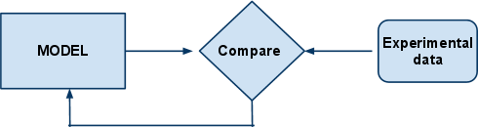

Both “input” data and experimental data are critical to the MSM effort, and ideally both types of data should be shared. The Data Sharing Working Group should address both data types but it might be wise to focus our initial efforts narrowly to increase our chances of success.

Data sharing and model sharing are complementary. Each model should be validated against data, and those data, as well as the models, should be in the public domain. Each addition of data to the database provides an opportunity to test the models further, extending their range of applicability or demonstrating inadequacies that need to be addressed through model refinement or replacement.

Obviously data sharing only makes sense if there is a community of investigators who are working on similar problems, and who see a need for common data. Perhaps the first task for us is to investigate whether the IMAG community actually sees a need for data sharing! And to try to identify the biggest perceived need.

B. How might data sharing be supported?

PhysioNet, and in particular PhysioNetWorks might be a suitable mechanism to support data sharing. ( http://physionet.org ) ( https://physionet.org/users/ )

QUESTIONS FOR DISCUSSION

1. Is there a perceived need and an interest among IMAG investigators to share data?

Yes

2. Should sharing be required by funding agencies (or is it already)?

Required but not enforced, timing is important

(raw and processed) data sharing should be required by journals (yes&no)
Major neuroscience journals formed a consortium to assist in sharing data – raw data posted online linked to original publication

Supplements are the current form for sharing – but only available to journal subscribers

3. How “open” should the sharing be?
Limited to IMAG?
Open to everyone worldwide? Yes
Relatively closed for a fixed period?

4. Data sharing makes most sense within modeling efforts in a similar domain.

Are there subsets of IMAG members who work in similar domains? Yes, e.g. Biomechanics WG
How do we identify investigators who are interested in data sharing?

5. Is PhysioNet Works a suitable mechanism to support data sharing within IMAG?

Yes
Advantages with repository sites
Also consider licensing in regard to re-distributing data

PhysioNetworks – secure, stable workspace to share data among groups, workspace is maintained in any format, standard, etc.
SIMTK.org – similar platform to allow data and model sharing, no requirements for type of data archived
Need national wide repository

No
Need a data standard – e.g. Semantic web documents found by Google
Keywords on top of an html document
NIfTI – data formatting is the priority for fMRI data analysis, http://nifti.nimh.nih.gov/
Bio-Formats – allow user to determine formats, http://loci.wisc.edu/software/bio-formats

Sharing Future Data vs. Sharing Existing Data
Can’t force people to share data
What can we gain from sharing data to promote research
Society for Neuroscience discussion – evolutionary tree of data sharing leading to different studies – NEUROINFORMTICS Volume 5, Number 3, 2007
Need to couple data with models
Biositemaps – RDF format, http://biositemaps.org/
Can the data from the different MSM models actually link?? Need to be shared?
Is there a body of data that would benefit the MSM if it were shared?
Provoke the existence of the database by having the model
Rational description of biology – could be data or model – that is the indexable part
No standard way of describing the model in biological terms
Give carrot to users to at least partially annotate data and models?
ChemDraw? Tool defined defacto format → standard data format
What tool can we give users to properly annotate data?
SBML – has no data (time series, validation data), describes model but not linkages to data – to come: Simulation Description Language (SDML), CellML is involved
Need tools to annotate data and models – QKDB – Quantitative Kidney Database
http://www.ncbi.nlm.nih.gov/pubmed/21325205--Integrating multiple types of data for signaling research: challenges and opportunities. Wiley HS. –Alison Dekhut
BIRN and ImmPort are also examples of databases designed for data sharing—Alison Dekhut

Next steps:
Identify 2-3 groups with similar modeling interests, and a need to share the data to do a data sharing experiment
Any volunteers??
Wishlist for data sharing?
Annotated metadata
Determine data that people wish to share
Time series data (1D and multidimensional)
Data that combine multiple scales
Biomechanics
Create subgroups based on data sharing interests

