Report on the French-American Joint Science & Education Workshop
Bordeaux, July 9th – 10th 2008
Purpose
To bring together scientists working on Computational Biology, Multi-Scale-Modeling, and Neuroscience from France and the US for a working meeting for presentation of established projects and identification of common interests and potential new collaborations, joint grants and exchanges of scientists and co-teaching of graduate students.
Support
Financial support for this workshop was provided by the Embassy of France to the United States and by Université Bordeaux 2.
Co-organizers:
US: Embassy of France a Washington, DC (Hedi Haddada)
Penn State University (Byron C. Jones)
National Institutes of Health (German Cavelier, Multi-Scale-Modeling initiative)
France: Université de Bordeaux 2 (Pierre Mormède)
Location: Building 'Plateforme de Génomique Fonctionnelle' Université de Bordeaux 2
Program
Day 1 (July 9th, 2008): Projects in Multi-Scale-Modeling Computational Biology
08h15 – 08h30 Welcome & Introduction - Pierre Mormède Université de Bordeaux
08h30 – 08h45 US French Embassy: Attaché Mission Scientifique, Hedi Haddada
08h45 – 09h00 IMAG and MSM - NIH & Funding Opportunities: German Cavelier, NIH/NIMH
09h00 – 09h30 The Virtual Physiological Human: Karin Johansson EC/VPH
09h30 – 10h00 CNRS Informatiques, Biologie Intégrative et Systèmes Complexes : S. Randall Thomas
10h00 – 10h30 Coffee
10h30 – 11h00 INSERM U642 Images and Models for Medicine (IS2M): Lofti Senhadji
11h00 – 12h00 Case Western Reserve University: Marco Cabrera - Attendee: Pierre Carlier
12h00 – 12h30 University of Tennessee Health Sciences Center: Rob Williams
12h30 – 14h00 Lunch
14h00 – 14h30 CNRS Centre de recherche cerveau et cognition : Simon Thorpe - Attendee: Thomas Serre
14h30 – 15h00 GIPSA-lab INPG Equipe Perception Visuelle : Denis Pellerin - Attendee: Jeanny Hérault
15h00 – 15h30 Laboratoire de Psychologie et NeuroCognition de Grenoble : David Alleysson
15h30 – 16h00 Break
16h00 – 17h00 Discussion

Day 2 (July 10th, 2008): Joint projects in Neuropharmacology, Neuroendocrinology
08h45 - 09h30 Introductions – principals and laboratories – Pierre Mormède, Byron Jones
09h30 - 10h00 The Bordeaux-Penn State collaboration – Pierre Mormède, Byron Jones
10h00 - 10h30 Coffee
10h30 - 11h00 The Strasbourg-Penn State collaboration – Anne Vasconcelos de Pereira, Byron Jones
11h00 - 11h30 Penn State Cavigelli Lab – Christina Ragan
11h30 - 12h00 Université Bordeaux I – Wim Crusio
12h00 - 13h30 Lunch
13h30 – 13h45 Student exchange programs – undergraduate – Byron Jones
13h45 - 14h00 Master in Neuroscience Programs
14h00 – 14h45 Joint Ph.D. Programs – Best Practices
15h00 Meet with President Manuel Tunon DeLara to sign agreement to pursue Memorandum of Understanding for Student and Researcher/Teacher exchanges
Individual Reports
German Cavelier
Due to administrative issues at the NIH, the time was not enough to get permission for German Cavelier to attend this international event, for which apologies are presented. Therefore, it was decided with the other organizers to do the presentation to the meeting over the internet, using teleconference tools provided by the NIH and a telephone call.
Thanks very much to the co-organizers, the other presenters and attendees for their successful and important help in this workshop that would have been impossible without their efforts. Hopefully this will be just the beginning of a long term activity between laboratories in France and the US. In particular, thanks to Pierre Mormede, Byron Jones and Hedi Haddada for their continuous help in the organization and for their participation. Also, thanks to Mario Cabrera for his help in chairing the session. In the presentation over the Internet at the Workshop in Bordeaux, German Cavelier used slides made by Grace Peng about the organization and function of the National Institute of Biomedical Imaging & Bioengineering, as well as of its IMAG and Multi-Scale-Modeling initiatives. The slides are easy to follow, and can be reached at the IMAG Wiki: http://www.imagwiki.org/mediawiki/index.php?title=France. As stated in the presentation, this meeting was a first approach to get the IMAG-MSM initiatives and related NIH Funding Mechanisms known to researchers in France and in Europe. The presentation by Karin Johansson (EC) was part of this joint effort, and all these activities will be followed by two important Multi-Scale-Modeling conferences that hopefully many of the parties involved will be able to attend: The “SIAM Conference on the Life Sciences”, August 4-7, 2008 in Montreal, Canada: http://www.siam.org/meetings/ls08/ and the October 23-24, 2008 “Computer Modeling and Simulation for Improving Human Health” conference in Brussels, Belgium http://ec.europa.eu/information_society/newsroom/cf/itemlongdetail.cfm?item_id=3956.

The coordinator of the IMAG and Multi-Scale-Modeling initiatives is:
Grace C.Y. Peng, Ph.D., Program Director
National Institute of Biomedical Imaging & Bioengineering
6707 Democracy Blvd., Suite 200, MSC 5469, Bethesda, MD 20892, USA
Telephone: 301-451-4778 Email: penggr@mail.nih.gov http://www.nibib.nih.gov/

MultiScale Modeling Funding Opportunity
FAQs: http://www.nibib.nih.gov/Funding/MultiscaleModeling
IMAG: http://www.nibib.nih.gov/Research/MultiScaleModeling/IMAG
IMAG Wiki: http://www.imagwiki.org/mediawiki

As noted in the IMAG Wiki, an “International Physiome” effort was launched by IMAG in 2008 with the purpose of
“… further promote International partnerships in the area of MultiScale modeling and simulation of human physiology and disease related processes resulting in predictive models for knowledge discovery and clinical applications (such as early diagnosis, novel personalized treatments and novel medical technologies.)” The rationale for this was that
“there are several national and international efforts focused on MultiScale modeling and simulation of human physiology and disease related processes. Examples of efforts being conducted around the world are listed at:
http://www.imagwiki.org/mediawiki/index.php?title=Multiscale_Modeling_of_the_Physiome_-_Projects_Around_the_World
“There is a growing realization that a concerted effort on the global scale needs to be pursued to accelerate progress and to avoid unnecessary duplication of effort. This need for global cooperation has been captured by a recent accord signed by researchers committed to pursue global cooperation in the field of integrative biomedical research”
http://www.biomedtown.org/biomed_town/VPH/wiri/OsakaAccord
“These efforts have a considerable potential to produce significant opportunities for synergistic collaboration across countries around the world, and lead to a greater impact on healthcare and economy around the world.”
“The work on patient specific MultiScale modeling and simulation is highly complex and requires the collection of good quality data to produce accurate predictive models across multiple scales. Global cooperation between the initiatives listed above will facilitate the sharing of research data, develop sharable and reusable modeling and simulation tools, promote coherent model validation, and accelerate translation to clinical applications.”
“Needs and Opportunities
- Benefits from the international collaboration may include: 1) a faster translation to clinical applications, and/or 2) a favorable environment for commercialization and economic development
- A need to develop methodologies and tools to provide the global research community with an advanced environment for integrative biomedical research (e.g. for sharing models and software tools, etc.)
- A need to promote new collaborations between US and international researchers (i.e. collaborators do not currently have joint funding), and utilized unique expertise and resources available in different countries.
- An opportunity to bring international research partners to the activities of IMAG/MSM Consortium and link the MSM Consortium to appropriate research efforts in the partnering country(ies)
- A need to open up dialogue between IMAG and funding agency counterparts from different countries
- A need to discuss Intellectual property rights pertaining to this field.
- A need to establish funds to travel to annual IMAG/MSM Consortium meetings.”
Pierre Mormède, Université Bordeaux II
Byron C. Jones, The Pennsylvania State University
Genetic Architecture of HPA axis under normal conditions and in animals fed a high-fat, high-carbohydrate diet. At present we are developing two related studies.
This project involves the use of the newly available BXD recombinant inbred (RI) lines derived from advanced intercrosses. The panel consists of 48 RI and the parental C57BL/6 and DBA/2 strains. At present, we have under review with the National Science Foundation, a research grant application to study the genetics/genomics of the HPA axis under normal conditions and following acute restraint stress. This is the third submission and previous review comments have been favorable with relatively minor corrections to be made.
In the planning stage is a proposal to the NIH to study the genetics of the HPA axis and its contribution to the metabolic syndrome (obesity, diabetes, inflammatory response) in the BXD strains fed a high fat, high carbohydrate diet. This is an important health-related problem and our approach is to study how the HPA axis changes in response to this diet and subsequently differences among strains in this response. The ultimate goal of this project is to identify the genes and gene networks in an effort to better understand the mechanisms of individual differences in the development of the metabolic syndrome.
This has been an active collaboration with 6 papers and two edited volumes having been produced. Additionally, Drs. Mormède and Jones are members of the Behavioral Neurogenetics Initiative, an organization that organizes 1-2 week schools and workshops in Behavioral Neurogenetics. Since its inception in 1994, this organization has conducted 13 schools in Europe (France, Sweden, Russia), North America (USA) and South America (Brazil).
Dr. Mormède is an adjunct faculty member of the Department of Biobehavioral Health at Penn State and Dr. Jones has spent more than a year in Dr. Mormède’s laboratory. Three Penn State students, including one postdoctoral trainee have spent from 6 months to 2 years in Dr. Mormède’s laboratory.

Anne Pereira de Vasconcelos – Université Louis Pasteur, Strasbourg
Byron C. Jones, The Pennsylvania State University
The interaction between methylenedioxymethamphetamine (MDMA) and alcohol.
This collaboration developed out of a visiting professorship for Dr. Jones at ULP. The principals besides Drs. Pereira and Jones include Drs. Jean-Christophe Cassel and Christian Kelche, Department of Psychology and Neuroscience Institute.
The research focus is to characterize the interaction between MDMA (or “ecstasy”) and alcohol. The former is a popular club drug taken by young people at dance parties (or “raves”) and often consumed with alcohol. To our surprise, until 2004, no basic research had been conducted in animals to study the physiological and behavioral effects of the combination, despite the fact that polydrug abuse is the rule rather than the exception. During the course of our work, we have shown that alcohol dramatically affects the thermoregulatory disruption caused by MDMA and that alcohol appears to increase the reward effect of MDMA. Moreover, we have shown that alcohol increases MDMA concentrations in the brain. Further research is planned to understand the mechanisms underlying the physiological and behavioral effects of this interaction.
This collaboration has yielded 8 published papers with 2 more having been submitted for peer-review.
Three Penn State students have spent at least one year in Dr. Cassel’s laboratory.

Hana Koutnikova, Elodie Bedu, Marie-France Champy, Roy Combe, Laurent Monassier, Stephanie Muller, Laurent Pouilly, Mohamed Selloum, Johan Auwerx, Institut Clinique de la Souris & IGBMC, Illkirch, France
Robert W. Williams, Kimberley J Acklin, Lu Lu,
University of Tennessee Health Science Center, Memphis, USA
Recombinant inbred BXD strains to map complex metabolic traits
French-American Joint Science & Education Workshop, Bordeaux, July 8th-10th 2008
The metabolic disorders and associated complications represent major cause of the morbidity and mortality in the developed countries. The World Health Organization estimates that by 2030 the diabetes mellitus, hypertensive heart disease, ischemic heart disease and cerebrovascular disease will be one of the ten major causes of death worldwide indicating that a need exists to treat and prevent these conditions. Understanding the genetic determinants of these complex polygenic disorders might help to design new strategies for pharmacological treatment and provide genetic counselling to the individuals at high risk to treat them efficaciously.
One strategy to identify the genes responsible for complex disorders, is to use the recombinant inbred populations such as the one generated by Prof. Rob W Williams. The mouse recombinant inbred strains represent a powerful and immortalized tool to analyze different phenotypes and underlying gene activities at the RNA or protein level. By combination of the genetic information, clinical data and gene expression changes it might be possible to trace different DNA variations responsible for the metabolic disorders.
For this purpose, the Institut Clinique de la Souris & IGBMC initiated phenotyping analysis of more than 20 different BXD recombinant strains kindly provided in an age matched cohorts by team from University of Tennessee Health Science Center, Memphis. This collaboration initiated by the end of 2006, provided already some preliminary data of potentially high clinical impact.
So far, 74 clinical traits were collected for each individual mouse for 23 and 25 BXD recombinant inbred strains in males and females, respectively. The following analysis leads already to the identification of new genetic locus that controls blood pressure. Fortunately, the involved genomic region is relatively small in size and of low gene density facilitating the candidate gene selection. Based on the available kidney gene expression data and bibliography survey, the candidate gene for blood pressure quantitative trait locus was identified. At present, human case control study is ongoing to test the hypothesis whether the candidate gene might play a role in development of hypertension in Askenazki Jewish population.
The collection of additional clinical data is ongoing and expected to be completed by Q3 of 2009. This will trigger the second phase of the projects, the gene expression analysis. Prof. Robert W. Williams and his colleagues provide the animals, genetic and gene expression data via GeneNetwork software and importantly, scientific knowledge, advice and very friendly frame to this efficacious collaboration. The Institut Clinique de la Souris & IGBMC provides the necessary tools and means to collect the phenotyping data, perform the analysis and interpret the data. It is perhaps not necessary to remind the large scope of such study in term of timing, animal and human resources and cost.
Beside the face to face exchange, data and resources review, the Bordeaux French American Joint Science & Education Workshop allowed us to perform some in-depth analysis based on newly available resources and delineate the following steps. A new contact with Dr. Wim Crusio from Bordeaux I university will likely lead to a more tight collaboration. Indeed, his group has acquired about 60 BXD recombinant strains during last years representing one of the largest BXD collections available worldwide. This might be of particular interest to pursue the preliminary outcomes on identification of genetic determinants underlying the blood glucose levels and glucose tolerance.

Signing of the agreement to pursue a formal Memorandum of Understanding for student and faculty exchanges between Université Bordeaux II and The Pennsylvania State University. President Manuel Tunon de Lara is on the left and Associate Dean Neil Sharkey is on the right.
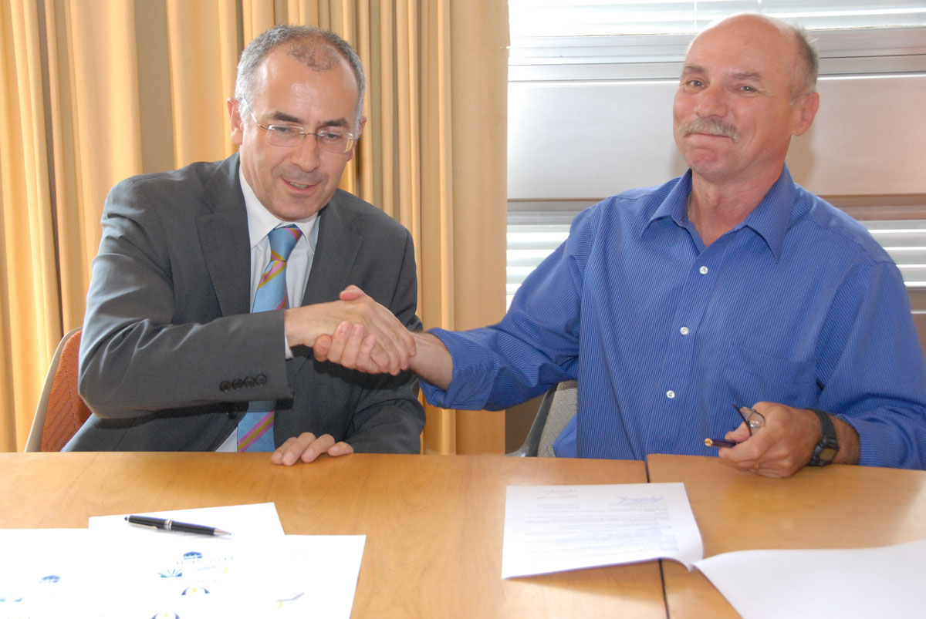

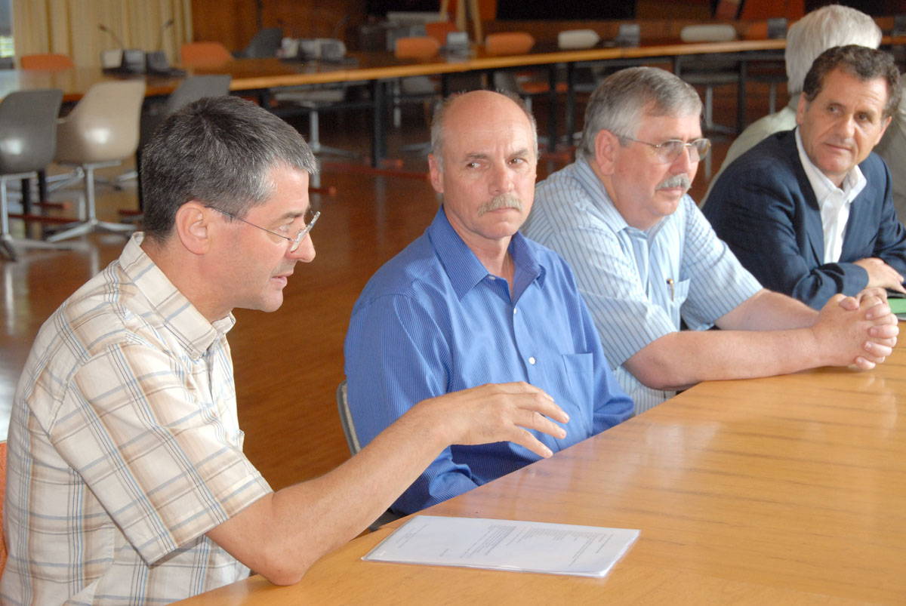
Left to right, Pierre Mormède, Neil Sharkey, Byron Jones, Hedi Haddada

