Multiscale Modeling of the Intracranial Vasculature
George Em Karniadakis, Division of Applied Mathematics, Brown University
Future petaflop simulations of realistic biological systems will necessarily involve concurrent multiscale modeling. Here, we address fundamental mathematical, algorithmic and software issues for simulating a human brain vascular model, the first of its kind, consisting of 100 large 3D arteries (Macrovascular Network, MaN), 10 million arterioles (Mesovascular Network, MeN) and one billion capillaries (Microvascular Network, MiN). We will present image-based 3D Navier-Stokes simulations for fully resolving MaN, coupled to subpixel stochastic simulations of MeN and MiN to complete the closure. In particular, we employ the quasi-1D Euler equations for the arteriolar tree, constructed from a fractal law with uncertain geometric and dynamical properties. For MiN, we will employ the stochastic Darcy's law, with an “effective” permeability obtained by pilot coarse-grained molecular dynamics simulations on stochastic replicas of capillary beds in conjunction with upscaling techniques. We estimate that these multiscale simulations will require no more than a few hours hours per cardiac cycle on the new petaflop systems, hence opening up the possibility of systematic studies to investigate normal brain perfusion and important clinical pathologies of the brain.
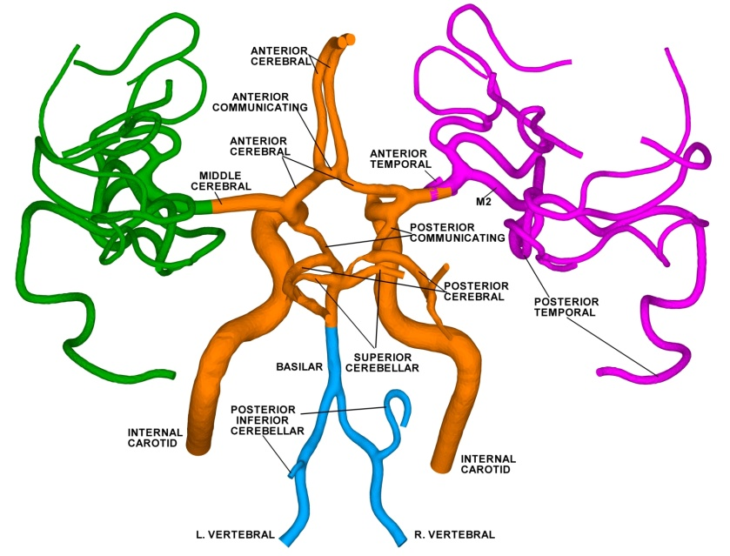 | 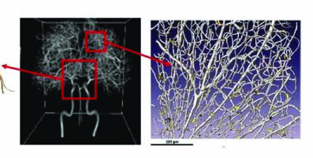

Figure 1: Deconstructing the vascular brain: (1) Macrovascular Network (MaN): Image-Based, down to 0.5 mm (3D NS); (2) Mesovascular Network (MeN) : Stochastic 1D PDE, down to 10 microns; (30 Microvascular Network (MiN): Stochastic replicas of capillary beds (Darcy & DPD)

