Lung : Cell Scale to Macroscale Integration

- Objective and Hypothesis

Airway defense is a multiscale process, involving mechanotransduction to transmit oscillatory mechanical force from macro scale (motion of lung, rib cage, diaphragm, and abdomen) to micro scale (airflow-induced shear stress and tissue stress at a local level), and further translation to biochemical responses via cell signaling to maintain the periciliary liquid (PCL) volume for mucociliary clearance. The broad objective of our research is to apply the image-based fluid-structure interaction (FSI) technique to study the mechanical force resulting from the multiscale interactions between pulmonary gas flow and lung tissue mechani, and its role in the distribution and progression of lung disease. A driving biological hypothesis providing one motivation for this work is that lung diseases alter mechanical force, which then alters stress-mediated adenosine triphosphate nucleotide (ATP) release, disturbs PCL water homeostasis, and weakens the integrated airway defense system, forming a vicious cycle of events. We speculate that airway bifurcation is particularly sensitive and vulnerable to the above pathologic process because local maximum stress is located in the vicinity of the bifurcation and increases substantially with airway stiffening and narrowing as found in the diseased lungs so that it can easily exceed the normal physiological range of stress. In the healthy lung, PCL and mucus - together with trapped inhaled bacteria and particulates - are continuously transported cephalad by coordinated ciliary beating. The bifurcation is a singular point where the inner walls of daughter branches meet and toxins/irritants accumulate; this is therefore a key weak spot in the network of mucociliary transport. A failure to maintain PCL water homeostasis near the bifurcation might effectively disrupt this defense pathway.
We plan to adopt a systems biology approach that integrates mechanics and cell models. The mechanics model utilizes imaging-based, high-fidelity computational technologies for three-dimensional (3D) fluid and solid mechanical systems to predict airflow-induced shear stress and tissue stress at a local level in the realistic human lung models. The cell model is based upon mathematical cell biology and in vitro data for epithelial cells and nucleotide metabolism to predict ATP release, cell metabolism, ion and water transport, PCL height, and calcium ion concentration [Ca²⁺]. The stress computed from the mechanics model is used as an input for the cell model. The predictions by the cell model can be mapped to the 3D airway geometry to test the above hypothesis.

- Cellular Response to Mechanical Force (link between scales)

The human bronchial epithelial (HBE) cells, like other cell types (e.g., endothelia), have mechanosensing capabilities that can detect changes to the extracellular micromechanical environment. The mechanical force exerted on the lung to change lung volume and pulmonary airflow can be transmitted from the organ level down to the levels of tissue, cell and molecule. From HBE cell culture experiments, Tarran et al., (2005, 2006) and Button et al. (2007, 2008) found that HBE cells respond to mechanical force. Figure 1 shows that the epithelial cells release ATP into the PCL in response to: (1) airflow-induced oscillatory shear stress and (2) (transepithelial) cyclic compressive stress (CCS). Here oscillatory (or phasic, cyclic as opposed to static) indicates inspiration/expiration of the airflow and expansion/recoil of the lung. CCS mimicks the transmural airway pressures of tidal breathing. Their major findings are: (1) HBE ATP release only responds to phasic motion, (2) the ATP release increases with increasing stress, but quickly reaches a plateau. These findings suggest that the rate of change of stress, not just its magnitude alone (due to phasic motion), is the important stimulus for ATP release into the extracellular PCL environment. ATP, along with its metabolite adenosine, interact with airway epithelial purinergic receptors, to up-regulate transcellular ion and water transports that increase PCL volume and ciliary beat frequency to accelerate mucus transport. HBE cells also protect themselves from over-stimulation and flooding of the airways by limiting ATP release during non-physiological stresses (refer to the plateau in Fig. 1). Thus, beyond the physiological range of stress, ATP release rates become less sensitive to higher stresses applied.

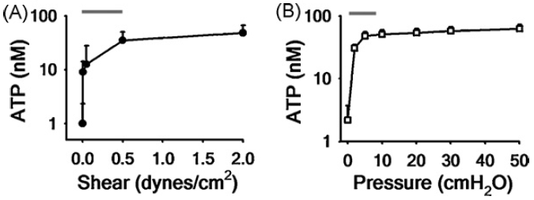
FIG. 1 Release of ATP during physiological stress. Relationship with magnitude of oscillatory (A) shear stress and (B) compressive stress. Red lines denote the physiological range of stress during tidal breathing (Button et al., 2008).

- Cell Model

In healthy subjects the PCL extends from the cell surface to a depth equal to the length of an out-stretched cilium. The cilia beat in a coordinated fashion at ~7Hz. If the PCL layer is not maintained at an adequate depth the cilia may become entangled in the mucus, and unable to disengage in the recovery stroke, resulting in no net movement of mucus. Conversely, if the PCL layer is too deep the cilia may be unable to contact the mucus to apply force. It is therefore imperative that ASL hydration is maintained within a specific tolerance, and hence it is one of the most tightly regulated microenvironments within the body. To maintain the optimal PCL depth of ~7µm, water movement into and out of the lumen is regulated through active ion transport. Normal airway epithelium has the capacity to absorb and secrete salt, predominantly Na⁺ and Cl⁻, thereby generating osmotic gradients which induce water flow across the epithelium. Figure 2 shows a schematic diagram of the mechanism by which ion channels, pumps, and cotransporters establish an osmotic gradient to drive water flow (Warren et al., 2008, 2009). The epithelial Na⁺ channel (ENaC) serves as the major conduit for Na⁺ through the apical membrane, and the Na⁺-K⁺-ATPase is the mechanism of basolateral extrusion. Transport of Cl⁻ through the apical membrane is primarily through the CFTR and the Ca²⁺-activated Cl⁻ Channel (CaCC).
Under a number of stress conditions airway epithelial cells release nucleotides into the lumen (see Fig. 2). Nucleotides act as signaling molecules to activate cell surface receptors, and are then degraded via ecto-nucleotidease activity. The P2Y₂ receptor plays an important role in this autocrine response. P2Y₂ receptors are G-protein coupled receptors (GPCRs), which act through the Gq/Phospholipase C pathway to produce the cytosolic signaling molecule IP₃ (inositol-triphosphate, a secondary messenger). Cytosolic IP₃ binds to Endoplasmic Reticulum (ER) receptors, triggering the release of calcium from the ER into the cytosol. Intracellular IP₃ concentration is known to be calcium dependent and this feedback is responsible for the characteristic oscillations of [Ca²⁺] concentration within the cytosol. The rise in [Ca²⁺] within the cell also activates CaCCs and Calcium-activated potassium channels (CaKCs) causing an osmotic gradient to form across the epithelium, which results in a flux of water into the lumen.
We plan to adopt a mathematical model that predicts PCL height and [Ca²⁺], i.e. disruption from PCL volume homeostasis leading to an intracellular Ca²⁺ transient reaction, in response to stress-mediated ATP release (Warren et al., 2008, 2009). The model has been compared against the experimental calcium traces of the rabbit tracheal epithelial cells upon stimulation with 0.1, 1, and 2 μM ATP (Zhang et al., 2003). The model predicts similar [Ca²⁺] oscillatory behaviors and pulsatile change of PCL height.

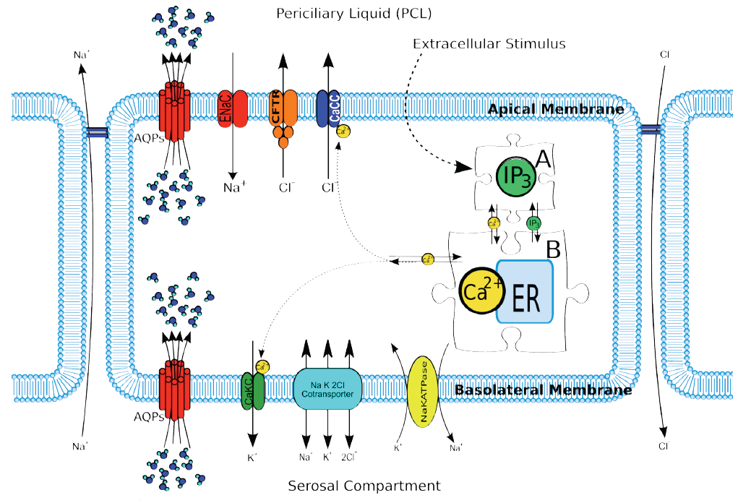
FIG 2. Schematic of epithelial model components (Warren et al.), showing the production of IP₃ after being triggered by an extracellular stimulus, the regulation of the inositolphosphate pool, and Ca⁺ handling of the cell activated through IP₃. AQPs, aquaporins.

- Mechanics Models

One-way and two-way FSI mechanics models may be adopted to predict stress distributions in the human lungs. In the one-way FSI approach, the fluid (CFD) and solid (CSM) solvers are executed separately. The boundary surface meshes between fluid (pulmonary gas flow) and solid (lung tissue mechanics) domains and the lobar and vessel tree boundary meshes are deformed using the image-registration derived displacement fields. The airway and lobe deformations are determined a priori to match as precisely as possible with CT images at different lung volumes, and then are provided to both solvers as Dirichlet boundaries. In the two-way FSI approach, the FSI interface between fluid and solid domains now are treated as internal nodes, and their positions and velocities are computed from the interactions between pulmonary gas flow and lung tissue mechanics. Any disagreement between the deformed airways (or the displacements of lung tissues) and those derived from image registration indicates that the FSI model has flaws caused by either prescribed lung biomechanical properties for CSM or lack of incorporation of detailed physiological processes into the model. A comparison between two-way and one-way FSI solutions allows identifying the potential source of the problem that causes the disagreement. One-way FSI is considered more accurate, but more restrictive, than two-way FSI because the former relies more on measurement data.

- Integration

A key component in the airway-defense system is “stress-mediated ATP release” that interconnects three scales: pulmonary airflow at the organ scale (which exerts shear stress on the airway liquid lining the epithelia), tissue tensile force at the tissue scale (which produces CCS on the epithelia), and epithelial cell response and signaling at the cellular/molecular scale (which releases ATP in response to cyclic stresses).

With the relationships between stress and ATP-release measured from cell culture experiments (Fig. 1), accurate prediction of ATP release (output), which up-regulates cell signaling and reaction to maintain PCL volume and hydration, relies upon accurate prediction of stress (input) that triggers its release in a location-specific and state-specific manner. Therefore, the stress computed from the mechanics model will be used as an input for the cell model. The cell model together with the thermodynamics laws for heat and moisture is then used to predict the biochemical responses of HBE cells and the regional distributions of PCL water level and [Ca²⁺] concentration. These predictions can be mapped to the 3D airway geometry to examine the aforementioned hypothesis.

- Limitation

- Single versus multiple types of cell models: Mechanical stress may simultaneously affect several cell types that shape and remodel airway structure, and vice versa. Here we only consider HBE cells.
- Liquid lining, mucus layer, and cilia: The airway surface liquid (ASL) lining covering the epithelia (PCL+mucus layer) is modeled as a compartment with dynamically changing depth; however we do not consider fluid interaction with the cilia in the PCL or the mucin release pathway. Whether cilia act as flow sensors in epithelia to transduce phasic stress is not known. Mucociliary clearance can be modeled by three different approaches: phenomenological, slender body theory, and FSI models (Smith et al., 2007, 2008; Yang et al., 2008), all from the mechanical point of view only.

