VV & UQ discussion support figure
Credibility discussion support figure
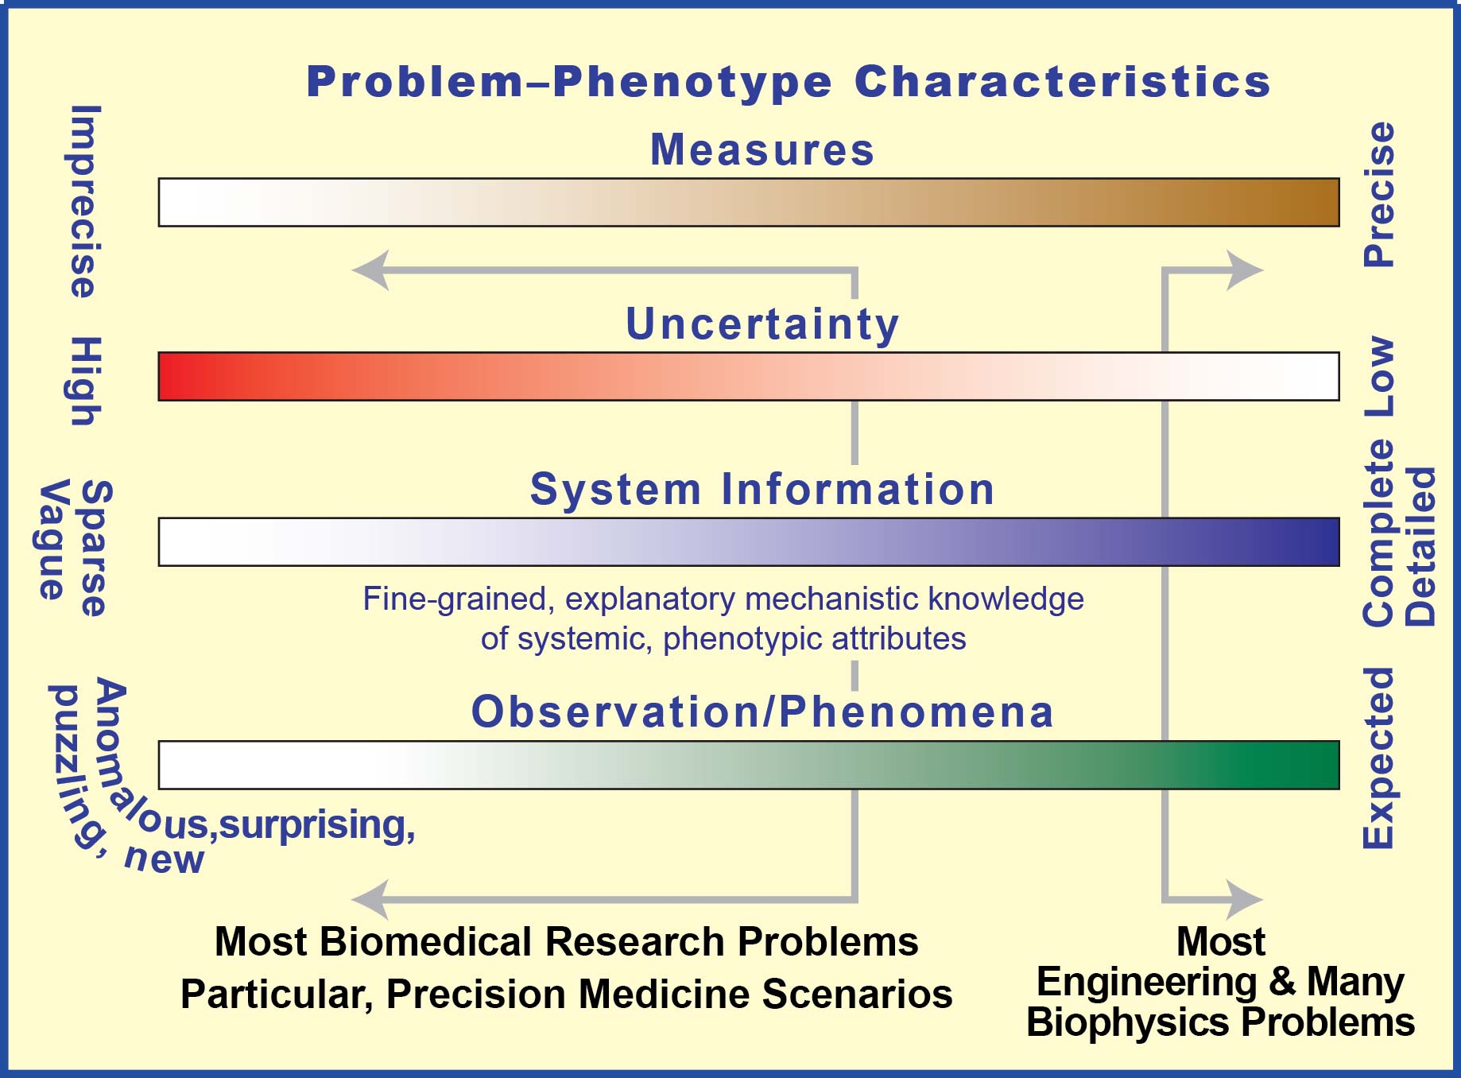
The scientific circumstances of any biomedical research or clinical problem can be characterized by indicating an approximate location on the four scales. Locations influence how one should approach establishing model credibility (when on the right: VV & U characterization). For Panel 4, models are envisioned, individualized, virtual patients (IVP) or their components. After IVP uses are specified, identification of locations on these scales helps identify requirements. Location also influences uses. Being far right is most supportive of using continuous mathematical models. Insisting on their use as one moves left requires accumulating assumptions (the further left, the more likely unjustified). On the right we can make trustable, precise predictions; reliance on absolute grounding is often appropriate. Center-left, the focus needs to be on mechanism discovery, explanation, and exploration. Reliance on object-oriented, discrete event, agent-oriented methods, and relational grounding is most appropriate.

