IMAG Working Group 3. December 2006, January 2007 Minutes.

Working Group 3: Cardiovascular and Pulmonary – Hemodynamics and Fluid Dynamics

Active vs. observer team breakout:

Kunz: Active member project 1
Lin: Active member project 2
Karniadakis: Active member project 3
Cabrera: Active member project 5
Kerckhoffs: Active member project 6
Hunter: Active member project 7

Hoffman, Tawhai: Observer members project 2
McCulloch: Observer member project 6
Brasseur: Observer member project 4

Represented IMAG projects:
Project 1) Multiscale Human Respiratory System Simulations To Study The Health Effects Of Aging, Disease And Inhaled Substances
Project 2) Multiscale Simulation Of Gas Flow Distribution In The Human Lung
Project 3) A Stochastic Molecular Dynamics Method For Multiscale Modeling Of Blood Platelet Phenomena
Project 4) Micro-Scale Transport As A Critical Link Between Molecular-Scale Absorption And Macro-Scale Mixing In Gut Physiology And Function
Project 5) Time Course Of Metabolic Adaptations During Loading And Unloading
Project 6) Multi-Scale Modeling Of The Mouse Heart: From Genotype To Phenotype
Project 7) Multiscale Modeling of the Heart in Metabolic Syndrome and Cardiovascular Disease

Minutes reported by WG3 lead Robert Kunz:

The main reporting items for December and January are:
- Breeze meeting on January 19.
- Development of Model-type definitions in the context of Cardiovascular dynamics

- On January 19 we held our third Breeze conference. Attendees were Chin-Long Lin from Iowa (Audio+Video), George Karniadakis from Brown (A+V), Marco Cabrera from Case (A only), Peter Hunter from the beach in New Zealand (A only), and Rob Kunz from PSU (A+V). Technically the conference went well with satisfactory bandwidth, George picking Breeze up quickly and Marco and Peter able to interact well despite being audio only. We remain happy with Breeze. Figure 1 illustrates a screen shot of the meeting room.

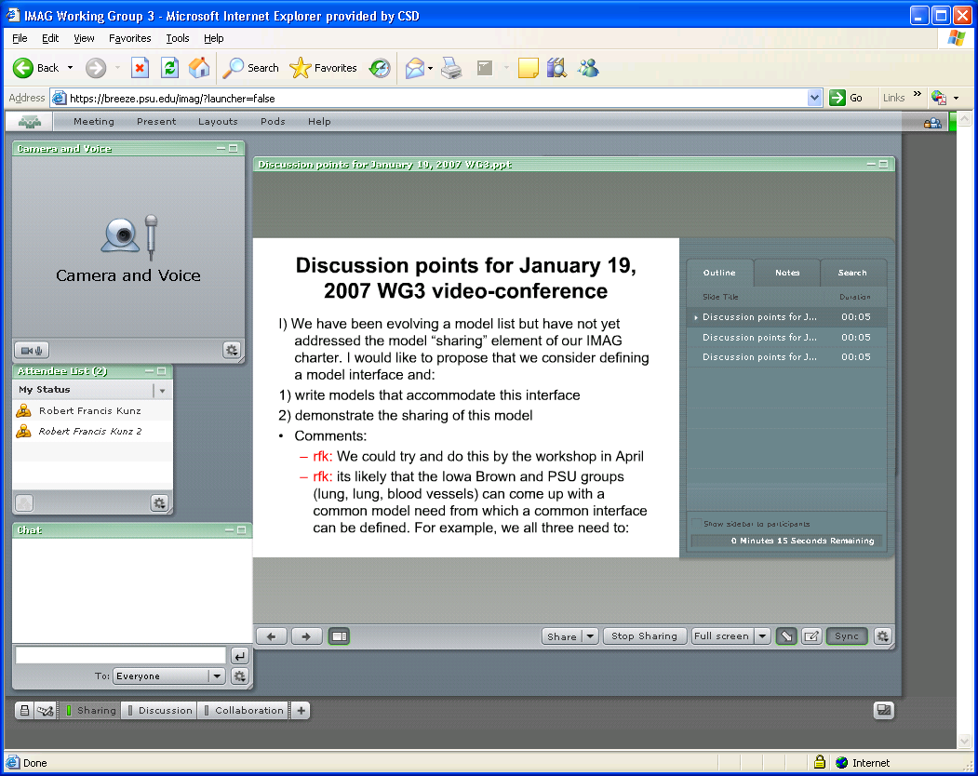
Video of all participants + microphone controls
Participant list and controls
Typed chat pod in case of connectivity problems
Shared content pod

Figure 1. IMAG WG3 Breeze Meeting room

The were two topics discussed, each of which is leading to a tangible model sharing “deliverable”. First we discussed how we might, as a working group, actually demonstrate the sharing of a model in the context of the macro-scale branching flow system CFD that groups 1-3 are pursuing. The discussion points used to engender this first discussion are included below:
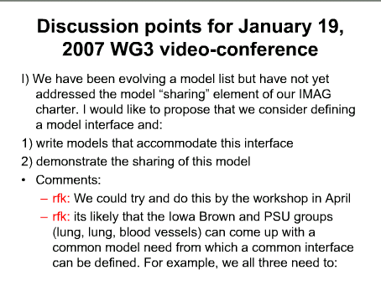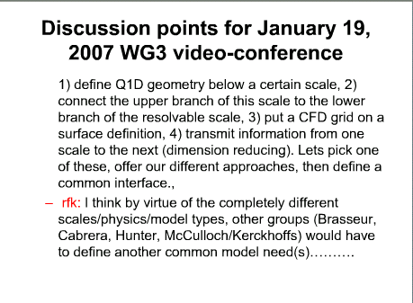
Lin, Karniadakis and Kunz will seek to define a common model need (likely among the four categories listed in slide 2, and attempt to define and demo a sharing prototype that is relevant to this class of bio-system modeling. My preference is #2 or #4 since these explicitly relate to multiscale models.
Of course the reason for that first discussion at all arises from concerns WG3 have come to in the past (and reported in previous progress reports), and that is that the macro scale branch system CFDers have some difficulty in appreciating the benefit of an XML based model sharing paradigm for their modeling needs. Accordingly what we are proposing, and hope to demo by April’s meeting, is not going to conform to such a sharing model, rather, an interface is likely to be defined in terms of a more conventional object-oriented software interface.
So this led us directly to the second discussion point. Since Marco and Peter were present, we discussed at length the different modes of model sharing that are relevant to our WG. We came up with four:
- Exchange of best practices
Lin, Kunz, Karniadakis believe that this share mode 1 is the most relevant to the macro branching flow CFD area. Here we envision publication, Breeze-like conferencing, and more general written and verbal communication of best practices and experiences as being the best way to propagate our modeling approaches. For example, Lin might find that using LES is critical to obtain certain deposition rates. How could he “share that model” without simply stating/publishing it with his numerical and validation evidence?

- Detailed models of application specific but common requirements
Share mode 2 is what we intended to capture in the first discussion above. For example, Kunz has a particular way of “connecting” the Q1D parent and daughter branches. This approach has precise definable geometric attributes, methods and performance. The attributes and methods can be collected into a C++ class that, with a well defined interface, could for example be exploited by Karniadakis in his blood flow simulations.

- XML based plug-and-play models
In share mode 3, we have models that are inherently well suited to closure laws. Some controversy remains within our group as to the relevance of such approaches to the macro scale simulations, but clearly certain models (e.g., deposition, non-linear branch wall stress-strain relations, turbulence modeling, gas diffusion modeling) could be conveniently adapted to such exchange mechanism.

- Multiscale approaches
Share mode 4 is a hybrid of the same macro model issues that motivate application-specific approaches, and the subgrid scale models that are more isotropic, or non-geometric/dimensional in nature. At the macro➔micro scale interface (say upper lung branches ➔ convective regime) this is as challenging as share mode 2. At the micro➔molecular scale interface share mode 3 may be relevant/acceptable.

