PI(s) of MSM U01: Danny Bluestein, Yuefan Deng, Marvin J. Slepian
Institution(s): Stony Brook University and University of Arizona, Tucson
MSM U01 Grant Number: U01HL131052
Title of Grant: Multiscale Modeling of Blood Flow and Platelet Mediated Thrombosis
Abstract
- Which MSM challenges are you addressing from the IMAG 2009 Report and how?
MSM challenges addressed and their implementation:
Challenge (1): We have developed sophisticated particle based methods to describe blood flow in cardiovascular pathologies and the ensuing mechanotransduction processes that may induce the initiation of thrombosis via flow induced platelet activation. A departure from the traditional continuum based approaches used to model such phenomena enabled us to circumvent inherent limitations of continuum based methods to cover the vast range of spatio-temporal scales that are required to describe the complex phenomena of flow induced thrombosis. The MSM methodology developed facilitates the integration of disparate scientific field such as fluid mechanics and cardiovascular disease processes by describing the mechanotransduction processes that couple the two.
Challenge (4): We are utilizing MSM to analyze the impact of clinically relevant shear forces generated via a range of devices and pathologies to predict cellular responsiveness driving thrombosis.
Challenge (8): Our MSM simulations utilize some of the strongest and fastest HPC resources around the globe, including the Sunway (National Supercomputer Center, Jinan, China), and the XSEDE (TACC on Stampede, and XSEDE on SDSC Comet), TX.
Challenge (9): Our MSM methodology is tightly coupled to extensive in vitro experiments with blood recirculating in microchannels using high end video microscopy to capture flow induced platelet shape change, activation, aggregation and deposition, and our hemodynamic shearing devices (HSD). A database of these experimental measurements is used to both validate the simulation predictions and train it, following a rigorous verification and validation (V&V) approach. Additionally, we employ various experimental techniques to establish the mechanical properties of the various cellular and subcellular components of platelets. To that end we have developed an innovative electrodeformation experimental approach to measure platelet stiffness and flexibility without touching the platelets. The data is fed into the MSM models to verify that the model provides a faithful representation of the flowing platelets. Our predictive multiscale models incorporate uncertainty quantification in the coarse graining procedure.
Challenge (15): Our models are used to test development of new anti-platelet therapeutic approaches, such as NLM – novel lipid moieties that modulate platelet membrane and other biophysical properties to make the platelet more shear resistant.
Challenge (16): Spatial scales covered range from macroscopic flow scales to mesoscopic cellular to sub-cellular and molecular atomistic levels (mm to nano). Temporal scales cover the range from milli to pico seconds). This was achieved by developing innovative models integrating Dissipative Particle Dynamics (DPD) with Coarse Grained Molecular Dynamics (CGMD) and developing dedicated Multiple Time Stepping (MTS) algorithms designed to reduce computation time by several orders of magnitude.

- Are you using machine learning and or causal inference methods and how?
We are using machine learning to predict the contact area conferred between aggregating platelets under shear flows using inputs extracted from our extensive experimental database. Implementation is via a feedforward neural network with 8 predictors (experimental inputs), two 10 nodes hidden layers- employing a Bayesian regularization algorithm, with the contact area as the output.
- Significant MSM achievements made (or expected).
  - Better understanding of the complex mechanotransduction processes involved in cellular response to mechanical stimuli, as represented by the vexing problem of flow mediated thrombosis.
  - Innovative multiscale algorithms utilizing HPC resources- leading to a true multiscale model depicting blood flow and platelet mediated thrombosis in cardiovascular diseases and in devices. This MSM model is developed following rigorous V&V practices.
  - Providing quantitative tools for developing improved pharmacological management of thrombosis by targeting the traditionally ignored mechanotransduction processes, as compared to existing empirics-based treatments.

- New MSM challenges that should be addressed by the MSM Consortium moving forward:
Combining continuum based finite elements simulation methods (e.g., CFD, structural, and FSI) with particle based methods (e.g., DPD, MD) to cover the vast range of scales in biological processes.

- Expertise of our team (the list below names the PIs only- the combined team has too many expert members to list here, including a Research Asst. Prof., post docs, and graduate students):
  - Danny Bluestein, Ph.D. Bioengineering- Thrombosis research: developing numerical and experimental methods for elucidating physical forces that regulate cellular function in flowing blood and optimizing thromboresistance in prosthetic blood recirculating devices. danny.bluestein@stonybrook.edu
  - Yuefan Deng, Ph.D., Applied Math. Developing parallel computing algorithms for a wide range of scientific problems. Developing molecular dynamics modeling. A specialist in parallelizing the optimization technique of simulated annealing. yuefan.deng@stonybrook.edu
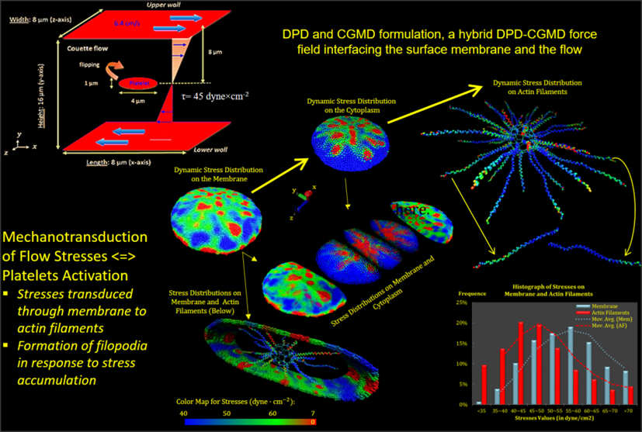
  - Marvin J. Slepian, MD, Interventional cardiology- Developing novel diagnostics and therapeutics for cardiovascular diseases, cell-matrix/material interactions, impact of physical forces on platelet activation and experimental techniques to measure them, innovation in medical devices, extensive clinical and industrial experience.

