2018 IMAG Futures Meeting – Moving Forward with the MSM Consortium (March 21-22, 2018)

Pre-Meeting Abstract Submission Form

*Please submit to the NIBIB IMAG mailbox (NIBIBimag@mail.nih.gov) by January 8th, 2018

PI(s) of MSM U01: Clancy, Colleen E

Institution(s): University of California Davis

MSM U01 Grant Number: U01HL126273

Title of Grant: PREDICTIVE MULTISCALE IN SILICO CARDIO-PHARMACOLOGY

Abstract

Which MSM challenges are you addressing from the IMAG 2009 Report and how?
https://www.imagwiki.nibib.nih.gov/content/2009-imag-futures-report-challenges
(indicate which challenge (#) you’re addressing)

You may insert images by copying and pasting below
7) Implementing virtual clinical trials with multiscale models to predict outcomes
Cardiotoxicity in the form of deadly abnormal cardiac rhythms is one of the most common and dangerous risks for drugs in development. Drug induced cardiotoxicity is one of the leading causes of drug attrition during development and accounts for 22-28% of US post-marketing drug withdrawal. There is an urgent need for new approaches to screen and predict the effects of drugs on cardiac rhythms. Our team is working on a new computer based technology called the “PharmaCoLogic preclinical screening technology” to fill the gap. Our technology will constitute the first solution, to our knowledge, that will allow for computer-based high throughput and low cost predictive screening of preclinical drug effects on the cardiac rhythm. We are developing a novel prototype PharmaCoLogic preclinical screening technology consisting of a multiscale computer-based modeling and simulation approach that predicts how drug interactions with cardiac ion channel targets at the level of the structural interaction and consequent kinetics link to drug induced cardiotoxicity. We expect the initial context of use for the PharmaCoLogic preclinical screening technology to be in the preclinical drug screening efforts to predict proarrhythmia outcomes.
8) Problem-driven multiscale models that require high performance computing (see below for available advanced computational resources): We have successfully obtained two allocations on the Anton Supercomputer and have recently received an XSEDE allocation.
18) Predictive multiscale models to improve clinical workflow, standard operating procedures, patient-specific modeling for diagnosis and therapy planning: We have developed a whole-cell model of Induced Pluripotent Stem Cell-Derived Cardiomyocytes iPSC-CMs) composed of single exponential voltage-dependent gating variable rate constants, parametrized to fit experimental iPSC-CM steady-state and time constant values for all major ionic currents. By optimizing the model parameters to multiple experimental datasets for each ionic current, we have implemented experimentally-observed variability in the driving ionic currents by varying gating parameters and current densities in the model. The resulting population of cells predicts robust inter-subject variability in iPSC-CMs, and is used to relate specific iPSC-CM phenotype variations to proclivity for arrhythmia. This methodology effectively links molecular mechanisms to cellular-level outputs by revealing unique subsets of model parameters linked to known iPSC-CM phenotypes, including proarrhythmic behavior. This study is the first step towards a computational method to integrate clinical and experimental data into a high throughput methodology to link patient-specific genotype-phenotypes relationships, and examine these relationships the presence of pharmacological intervention.

Are you using machine learning and or causal inference methods and how?
You may insert images by copying and pasting below
N/A

Please briefly describe significant MSM achievements made (or expected).

You may insert images by copying and pasting below
We have undertaken structural modeling of local anesthetic and antiarrhythmic drug binding to the human cardiac voltage gated sodium channel. The human voltage gated sodium (Na_{v}) channel, hNa_{v}1.5, is predominantly expressed in cardiac myocytes and is responsible for the rapid upstroke of the cardiac action potential. hNa_{v}1.5 channel plays a central role in congenital and acquired cardiac arrhythmias and has been a key target for drug development. Mutagenesis studies have previously identified key residues in Na_{v} channels S6 segments from domains III and IV that form a receptor site for binding of local anesthetic and antiarrhythmic drugs. However, the structural details of how these drugs affect Na_{v} channel function are not well understood. We have now successfully utilized Rosetta computational modeling software to build a homology model of human Na_{v}1.5 in open-inactivated and closed states based on the cryo-EM structures of electric eel Na_{v}1.4 (PDB ID: 5XSY) and American cockroach NavPaS (PDB ID: 5X0M), respectively. We applied the RosettaLigand molecular docking program to study hNa_{v}1.5 channel interactions with local anesthetic and antiarrhythmic drugs, including lidocaine, etidocaine, QX-314, ranolazine, flecainide and GS967. Our lowest energy models have shown that both local anesthetic and antiarrhythmic drugs bind to hNav1.5 via a common receptor site formed by S6 segments from domains III and IV in the central pore. We are utilizing these results now to further advance structural understanding for molecular mechanisms of local anesthetic and antiarrhythmic drug interaction with hNa_{v}1.5 and provide useful insights towards the rational design of novel modulators of ion channel activity for the treatment of cardiac arrhythmias.

Using previously developed homology models to establish methods for computing affinities for drugs and the cardiac Na channel, we carried out two sets of simulations in order to assess the differences in likely binding positions of lidocaine within the open and closed pore modelsParameters for the neutral lidocaine molecule were obtained using generalized CHARMM force field (CGENFF) for drug-like molecules and optimized using standard protocols using experimental observables and quantum mechanical (QM) data as a reference. Unbiased MD Simulations: In these simulations, neutral lidocaine exhibits multiple nonspecific binding modes within the pore, below the selectivity filter, and above the activation gate, in both open and closed states. These binding modes were dominated by hydrophobic interactions including a canonical binding site of F1760 between domains III and IV, which was also observed in docking simulations. The probability of lidocaine occupying the top three interaction sites (clusters) over the combined 180ns of unbiased simulation was computed as the fraction of time occupied by lidocaine, per site. In the closed state, lidocaine was almost equally likely to embed deep in the fenestrations between domains III and IV or domains I and IV, but in the open state model it was slightly more likely to embed between domains I and II or domains II or III, however in the open state the lidocaine molecule embedded less deeply into each fenestration with more of the molecule residing in the aqueous pore. In all cases, the van der Waals energetic contribution dominated in the interactions. We also carried out Biased MD Simulations – Metadynamics: The energetic bias employed in metadynamics simulations of lidocaine in the pore models of Na_{V}1.5 was sufficient to allow the sampling of lidocaine egress from the pore into bulk water solution in the open-state model, in which it overcame an energetic barrier of ~10kcal/mol (Figure 1B). However, in the closed state model lidocaine remained trapped, sampling other fenestration regions at the top of the pore (Figure 1A), below the selectivity filter the selectivity filter (SF), and unable to overcome an anergetic barrier of over ~20kcal/mol to exit from the pore into either the bulk intracellular solution or the intra-membrane space through a fenestration.

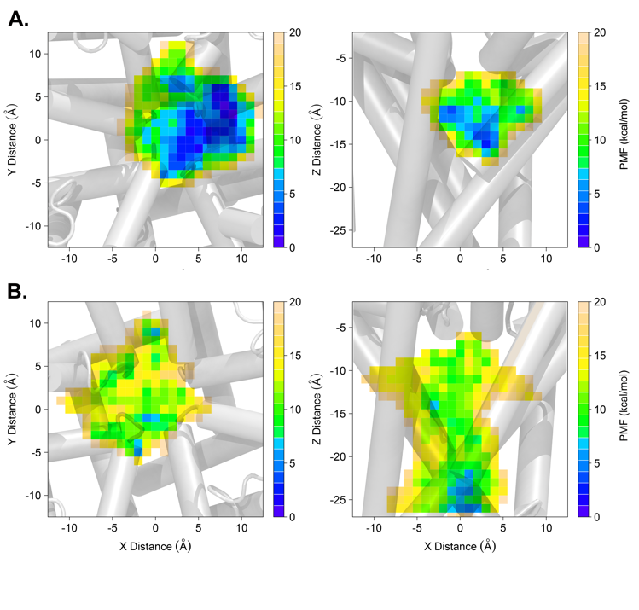
Figure 1. Surface projections of the potential of mean force derived from metadynamics simulations. A. Closed state and B. open state models of Na_{V}1.5 overlaid onto potential of mean for surfaces in the x-y plane (left) and x-z plane (right). Enhanced sampling of pore further confirmed interaction with the fenestration regions found in clustering analysis, particularly with the fenestration between domains DIII and DIV.

Interaction of drugs with cardiac ion channels is mediated in large part by the propensity of a drug to passively diffuse into the cell from the extracellular space, and therefore lipid membrane permeation of a drug is a critical factor in its pharmacokinetics. However, at the molecular level, little is known about the specific ionization states, spatial localization, or aggregation patterns of drugs in lipid bilayers, all of which can factor into potency, toxicity, and ability to bind to different sites in cardiac ion channels. Therefore, we developed biomolecular CHARMM force field compatible parameters for a small set of known cardiac ion channel blockers with varying risk propensities for arrhythmogenesis, and used all-atom molecular dynamics simulations to compute kinetics and thermodynamics of their partitioning through hydrated lipid membranes for different drug ionization states. We have developed an approach to determine water-membrane distributions and permeability rates for the drug translocation into the cell, and thus propensities for lipophilic and aqueous access to cardiac ion channel protein targets.
Please suggest any new MSM challenges that should be addressed by the MSM Consortium moving forward. You may insert images by copying and pasting below
Click or tap here to enter text.
What expertise are on your team (e.g. engineering, math, statistics, computer science, clinical, industry) and who?
Please list as “Expertise – Name, email”
Atomistic Modeling and Simulation - Igor Vorobyov
Protein, cell and tissue level functional simulation - Colleen E. Clancy
Structural models and de novo modeling - Vladimir Yarov-Yarovoy
Dynamical Systems, Mathematical Analysis- Timothy Lewis
*Save your abstract as “MSM PI Last Name _ 2018 IMAG Futures Pre-Meeting Abstract”
Click here to email your form to the NIBIB IMAG mailbox

