Title: Multi-scale mechanics of the tendon-to-bone attachment
Authors: Stavros Thomopoulos, Victor Birman, Markus J. Buehler, Ioannis Chasiotis, Alix C. Deymier, Mikhail Golman, Guy M. Genin
Presenter: Mikhail Golman
Joint motion is achieved via transfer of muscle load from tendon to bone. This linkage includes tissues with dramatically varying compositions, structures, and mechanical properties. From the continuum perspective, the moduli of tendon and bone along the direction of muscle force differ by nearly two orders of magnitude, and the Poisson ratios for stretching in this direction can differ by nearly an order of magnitude. From the structural perspective, both are hierarchically organized, with nanoscale tropocollagen triple helices bundling into micrometer-diameter fibrils, which in turn bundle into fibers that are hundreds of micrometers in diameter and many millimeters long (Fig. 1). In bone, the fibrils are stiffened by bioapatite mineral crystals that insert within, coat, and cross-link the fibrils. The tendon-to-bone attachment would be expected to fail from Bogy- or Williams-type free edge singularities if stress concentrations at the interface were not attenuated with a suite of cross-scale deformation mechanisms. Indeed, the rates of failure after surgical repair of tendon to bone pose a major challenge, with astounding failure rates in some cases. How, then, does the healthy tendon-to-bone attachment achieve effective load transfer from tendon to bone? The answer lies in a unique hierarchical transitional tissue that exists at the interface between the dissimilar materials (Fig. 1). Randomness has emerged as a key structural feature of effective stress transfer between the two tissues, with randomness described in: (1) mineral deposits, (2) interdigitation, and (3) collagen organization. Transmission electron microscopy imaging of the tendon-to-bone attachment showed that the mineral gradient is not smooth when examined at the nanometer length scale. Imaging at larger length scales as well has revealed roughness, with stochastic interdigitation between tendon and bone. Finally, the role of disorder in the orientation distribution of collagen has long been known. These features combine to toughen the attachment and provide effective stress transfer between tendon and bone. [ST and GMG acknowledge funding from NIH EB016422.]
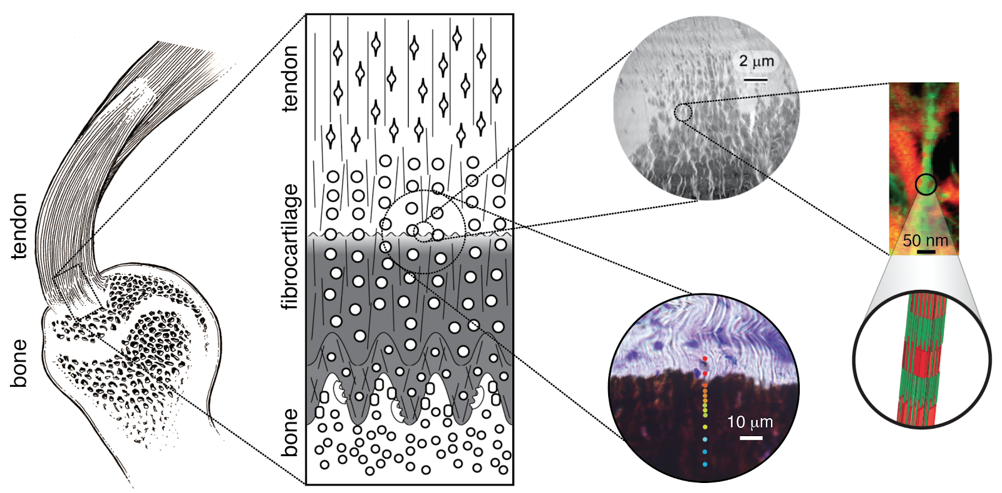
Figure 1. The hierarchical structure of the tendon-to-bone attachment. Tendon inserts into bone over what can appear as a disordered, smooth, or sharp fibrocartilaginous transition, depending upon the length scale of observation. At the highest (cm, left) and lowest (nm, right) length scales, the tissue and transitions appear ordered and smooth. However, at the mesoscale of 100s of nm to 10s of micrometers (images in circles, third from left), reports of important roles of stochastic material distributions have emerged.

