2018 IMAG Futures Meeting – Moving Forward with the MSM Consortium (March 21-22, 2018)
Pre-Meeting Abstract Submission Form
*Please submit to the NIBIB IMAG mailbox (NIBIBimag@mail.nih.gov) by January 8th, 2018
*Save your abstract as “MSM PI Last Name _ 2018 IMAG Futures Pre-Meeting Abstract”

PI(s) of MSM U01: David M. Eckmann and Ravi Radhakrishnan
Institution(s): University of Pennsylvania
MSM U01 Grant Number: U01 016027
Title of Grant: Bridging Multiple Scales in Modeling Targeted Drug Nanocarrier Delivery

Abstract

Which MSM challenges are you addressing from the IMAG 2009 Report and how?
https://www.imagwiki.nibib.nih.gov/content/2009-imag-futures-report-challenges
(indicate which challenge (#) you’re addressing)
You may insert images by copying and pasting below
#5. Reproducible and reusable multiscale models that will be integrated and adopted into model-poor fields (e.g. tissue engineering, regenerative medicine, drug and gene delivery, preventive interventions)

Are you using machine learning and or causal inference methods and how?
You may insert images by copying and pasting below
No

Please briefly describe significant MSM achievements made (or expected).
You may insert images by copying and pasting below
We developed a multiscale and multimodeller computing platform for the design of functionalized nanoparticles (NPs) for applications in disease imaging and targeted drug delivery. (1) At the hydrodynamic scale we capture detailed hydrodynamic interactions of different shaped NPs in the presence of confining boundaries such as blood vessel wall and with adhesion interactions. We include flexible NPs and interactions mediated by red blood cells. (2) At the adhesion scale we capture multivalent interactions between NPs and the cellular surface and include effects of compliance of a live cell membrane, glycocalyx, cytoskeleton, and cell surface heterogeneity. We compute binding avidity (effective association equilibrium constant for multivalent interactions) for rigid and flexible NPs by accounting for enthalpic and entropic terms. (3) At the Pharmacokinetics scale we developed a next-generation pharmacokinetics model to integrate our results from the hydrodynamics and adhesion scales into results for tissue targeting in vivo. We include targeted, untargeted, and clearance mechanisms, as well as use big data repositories (e.g., The Cancer Genome Atlas) to profile molecular expression in a patient specific fashion. (4) We validated our models by comparing each scale of computation separately with independent experiments, and we validated the tissue biodistribution using in vivo measurements. We make predictions for rats and humans based on customizing the physiological and molecular parameters of our model. Physical and single molecule experiments were conducted to guide the choice of parameters for molecular interactions. The successful comparison and validation were achieved for a diverse range of nanoparticles including rigid spherical particles, flexible biocompatible nanogels, and nanoparticles made through DNA origami. The biomedical applications for our rational targeting platform include lung inflammation, and the actute respiratory distress syndrome.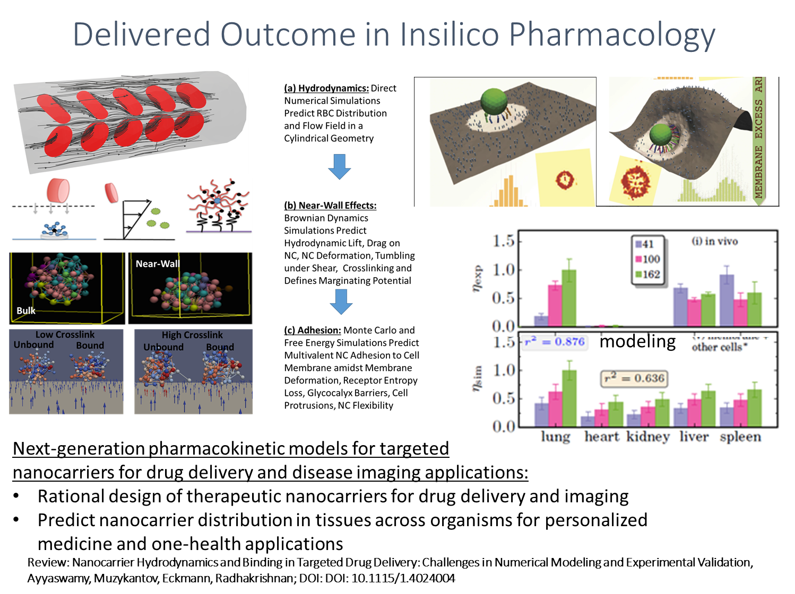

Please suggest any new MSM challenges that should be addressed by the MSM Consortium moving forward.
You may insert images by copying and pasting below
The quantitative description of multiple scales in biological processes are based on theories and models from different fields (e.g, systems biology, continuum mechanics, hydrodynamics). Clinical and health data are heterogeneous ranging from medcial records, imaging data, to molecular profiling. To integrate this diversity, MSM can explicitly focus on heterogeneous multiscale methods or Multimodeller Hyper Models which combine disparate models into one process/simulation framework.

What expertise are on your team (e.g. engineering, math, statistics, computer science, clinical, industry) and who?
Please list as “Expertise – Name, email”
Clinical, Engineering - David M. Eckmann, eckmanndm@uphs.upenn.edu; Engineering, Math – Ravi Radhakrishnan, rradhak@seas.upenn.edu; Pharmacology – Vladimir Muzykantov, muzykant@mail.med.upenn.edu; Engineering, Math – Portonovo Ayyaswamy, ayya@seas.upenn.edu; Engineering – Andrew Tsourkas, atsourk@seas.upenn.edu

*Save your abstract as “MSM PI Last Name _ 2018 IMAG Futures Pre-Meeting Abstract”
Click here to email your form to the NIBIB IMAG mailbox

