2018 IMAG Futures Meeting – Moving Forward with the MSM Consortium (March 21-22, 2018)
Pre-Meeting Abstract Submission Form
*Please submit to the NIBIB IMAG mailbox (NIBIBimag@mail.nih.gov) by January 8th, 2018
*Save your abstract as “MSM PI Last Name _ 2018 IMAG Futures Pre-Meeting Abstract”

PI(s) of MSM U01: Guy Genin, Stavros Thomopoulos
Institution(s): Washington University (GG), Columbia University (ST)
MSM U01 Grant Number: U01 EB016422
Title of Grant: Cross-scale interactions between mineral and collagen for tendon-bone attachment

Abstract

Which MSM challenges are you addressing from the IMAG 2009 Report and how?
https://www.imagwiki.nibib.nih.gov/content/2009-imag-futures-report-challenges
Joining of dissimilar materials is a fundamental challenge in engineering. Nature presents a highly effective solution at the attachment of tendon to bone ("enthesis"), e.g., in the rotator cuff -humeral head interface in the shoulder. Pressing needs exist both to understand the mechanics and biology of adhesion and toughening across hierarchical scales in the healthy enthesis, and to reconstitute these in healing. Our work is addressing two challenges from the IMAG 2009 report in the context of attaching dissimilar materials: (5) Reproducible and reusable multiscale models that will be integrated and adopted into model-poor fields (e.g. tissue engineering, regenerative medicine) and (9) Model predictions that drive a community of experimentalists towards systematic testing and validation. Models have been developed from the molecular through the tissue scales, and validated using experimental mechanical testing. These models can now be used to drive the design criteria and implementation of tissue engineering efforts to synthesize tough tendon-to-bone attachments for clinical use.
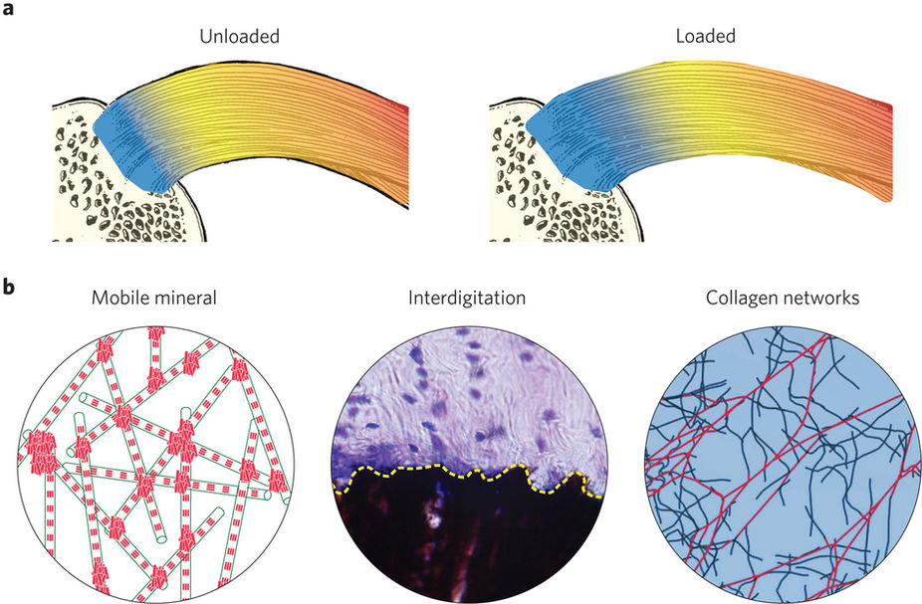
a, The disordered, energy-absorptive barrier model. Deformation localizes to the enthesis site (blue) due to its high compliance relative to bone (tan), tendon (yellow) and muscle (red). This high compliance arises in part from the character of the tissue at the attachment site, which is now known to behave like a fibrous network. b, This tissue is expected to be exceptionally tough relative to the neighboring tissue because of the three known components of disorder at the enthesis site: randomly distributed, mobile mineral (red plates); interfacial roughness (yellow dashed line); and the newly identified disordered fiber arrays (loaded fibres in red; unloaded fibres in blue). From Genin and Thomopoulos, Nature Materials 16, 607–608 (2017).
Are you using machine learning and or causal inference methods and how?

Multiscale failure analysis inherently involves causal inference. We apply causal inference in all of our failure analyses to determine how quantifiable heterogeneity at the nano-, micro-, and meso-scales relate to toughness of tissues. The preliminary results of these analyses show a tradeoff between strength in toughness as certain types of heterogeneity increase.
From the experimental side, we have developed novel computer vision algorithms to assess the processes that lead to failure. These algorithms measure local strain patterns in deforming materials. These methods have been implemented in 2D and 3D and provide, for the first time, a robust method to identify local strain concentrations predictive of local failure.

Please briefly describe significant MSM achievements made (or expected).

Our recent results suggest that the hierarchical architecture presents cross-scale order for the purpose of strengthening the enthesis against injury, and cross-scale disorder for toughening the enthesis against failure. Understanding the latter represents an important frontier for the field. Initial studies suggest that disorder maximizes the fraction of tissue involved in resisting catastrophic injury-level stresses. Based upon this model, we are developing two new mechano-medicine products for clinical translation: a diagnostic technology to evaluate the degree to which an enthesis is succeeding in physiological strain redistribution, and a repair technology that mimics the mesoscale function of the healthy enthesis by maximizing the fraction of tissue involved in resisting injury-level stresses.

Please suggest any new MSM challenges that should be addressed by the MSM Consortium moving forward.
MSM has historically focused on understanding and harnessing order across hierarchies. Recent results suggest that order is critical for properties such as strength, flow, and conduction, whereas heterogeneity and disorder are critical for properties such as toughness, mixing, and redundancy. Modeling the latter is challenging and computationally expensive because techniques such as Monte Carlo approaches must be used. A pressing need exists for sound homogenization methods that predict properties of disordered tissues.

What expertise are on your team (e.g. engineering, math, statistics, computer science, clinical, industry) and who?

Engineering (modeling, nano through milliscale) – Guy Genin (genin@wustl.edu)
Engineering (experiments), Regenerative Medicine – Stavros Thomopoulos (sat2@columbia.edu)
Engineering (modeling, nanoscale) – Markus Buehler (mbuehler@mit.edu)
Engineering (modeling, micro through milliscale) – Victor Birman (vbirman@mst.edu)
Engineering (modeling, micro through milliscale) – Pedro Ponte Casteñada (ponte@seas.upenn.edu)
Engineering (experiments, microscale) – Ioannis Chasiotis (chasioti@illinois.edu)
Materials Science (biomineralization) – Alix Deymier (alix.c.deymier@gmail.com)

