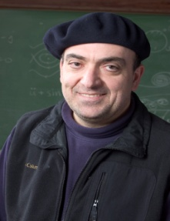

George Karniadakis is the Charles Pitts Robinson and John Palmer Barstow Professor of Applied Mathematics at Brown University. He is one of the founders of the IMAG/MSM ten years ago and he has received funding continuously since then. He received his S.M. (1984) and Ph.D. (1987) from Massachusetts Institute of Technology. He was appointed Lecturer in the Department of Mechanical Engineering at MIT in 1987 and subsequently he joined the Center for Turbulence Research at Stanford / Nasa Ames. He joined Princeton University as Assistant Professor in the Department of Mechanical and Aerospace Engineering and as Associate Faculty in the Program of Applied and Computational Mathematics. He was a Visiting Professor at Caltech (1993) in the Aeronautics Department. He joined Brown University as Associate Professor of Applied Mathematics in the Center for Fluid Mechanics on January 1, 1994. He became a full professor on July 1, 1996. He has been a Visiting Professor and Senior Lecturer of Ocean/Mechanical Engineering at MIT since September 1, 2000. He was Visiting Professor at Peking University (Fall 2007 & 2013). He is a Fellow of the Society for Industrial and Applied Mathematics (SIAM, 2010-), Fellow of the American Physical Society (APS, 2004-), Fellow of the American Society of Mechanical Engineers (ASME, 2003-) and Associate Fellow of the American Institute of Aeronautics and Astronautics (AIAA, 2006-). He received the Ralf E Kleinman award from SIAM (2015), the (inaugural) J. Tinsley Oden Medal (2013), and the CFD award (2007) by the US Association in Computational Mechanics. His h-index is 78 and he has been cited over 31,000 times. His research interests focus on stochastic multiscale mathematics and modeling of physical and biological systems. Current thrusts include machine learning and scientific computing, stochastic simulation (in the context of uncertainty quantification and beyond), fractional PDEs, and multiscale modeling of complex systems.

