Multiscale Modeling of Blood Flow and Platelet Mediated Thrombosis
Peng Zhang¹, Jawaad Sheriff¹, Prachi Gupta¹, Marvin J. Slepian², Yuefan Deng¹ and Danny Bluestein¹
¹Stony Brook University, Stony Brook, NY, ²University of Arizona, Tucson, AZ.

Introduction: The coagulation cascade of blood may be initiated by flow induced platelet activation, which prompts clot formation in prosthetic cardiovascular devices and in arterial disease processes. Upon activation, platelets undergo complex morphological changes of filopodial formation that play a major role in aggregation and attachment to surfaces. Continuum methods fail to capture the molecular-scale mechanism such as filopodial formation. Utilizing molecular dynamics (MD) to model this is computationally prohibitive. We developed a multiscale model which interfaces nanoscale microstructures of platelets and microscale transport of blood flows, for providing a more accurate flow-induced dynamic stress mapping on platelets and predict their activation .
Materials and Methods: Our multiple spatiotemporal model employs a modified dissipative particle dynamics (DPD) to describe viscous blood flows in the case of stenosis¹; an electrical-free coarse-grained MD (CGMD) to describe the platelet membrane, the cytoplasm and the cytoskeleton. CGMD is composed of nonbonded potentials (Lennard-Jones and Morse³) and bonded potentials (bonds, angles and dihedrals). Spatially, the DPD-CGMD interface was established by imposing a hybrid force field ⁴. Temporally, a novel 4-level multiple time-stepping (MTS) scheme was developed ⁶ as an efficient and scalable numeric solver on top supercomputers ⁷.
Results and Discussion: This model describes the nanoscale mechanotransduction and biophysics of deformable platelets under viscous blood flows⁵. Fig.1 shows the platelet activation process: the platelets continuously change their morphology while reflecting the microstructural changes of platelets in response to these extracellular stresses that are transferred to them; in the meanwhile, the hemodynamic stresses that may lead to activation and filopodial formation are mapped on the membrane and transferred to the cytoskeleton while the platelets are flowing and flipping; last, filopodial formation is stimulated for these filaments which are exposed to the highest stresses. The resultant filopodia formation compared favorably with in vitro measurements. Fig. 2 shows platelets aggregation correlating with in vitro results. We mimicked the aggregation of two platelets in a microchannel under a share rate of 8000 s⁻¹. The contact time is 0.2~1.0 ms and the contact area is ~ 0.2 μm², which deceases almost linearly with an increase in the microchannel width. These correlated with the in vitro experiment results.
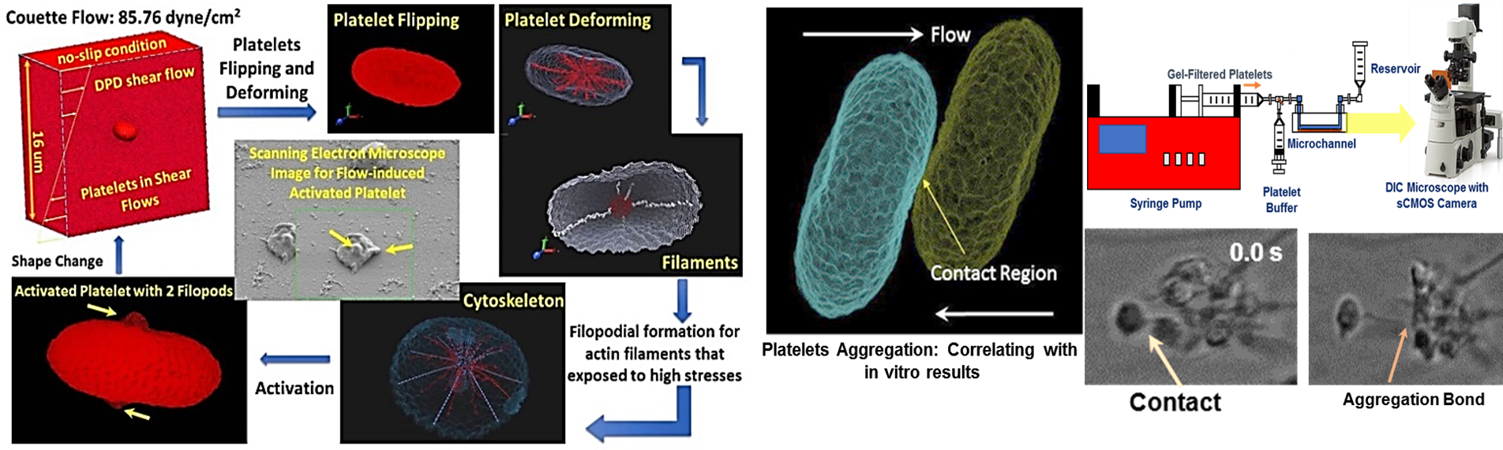
Conclusions: Our multiscale numerical approach offers a computationally affordable and highly resolved method for modeling platelet activation in shear flows. Biophysical properties of the deformable platelets are accurately described down to the nanoscales. Hemodynamic stress is mapped on membrane and intra-platelet components. The filopodia formation is mimicked and correlate with in vitro microchannel experiments. This model can be further employed to simulate other processes involved in platelet activation, aggregation and adhesion, offering a practical multiscale method for solving complex clinical problems at the juncture of biology and engineering.
Fig 1: Flow induced platelet activation (2-filopods).
Fig 2: Platelets aggregation correlating with in-vitro result.
Fig 2: Platelet aggregation- initial contact and correlation with in vitro measurements

Acknowledgements: This project was funded by NIH (U01 HL131052, R21 HL096930-01, U01 EB012487, Bluestein, D.). This project used the XSEDE computer resource awards (DMS140019, DMS150011, Zhang, P.).
References: [1] Gao, C., et al, J Comput Phys, 335:812-827, 2017. [2] Pothapragada, S., et al, Int J Numer Meth Biomed Engng, 31:1-16, 2015. [3] Zhang, N. et al, J Comput Phys, 257:726-736, 2014. [4] Zhang, P., et al, Cell Mol Bioeng, 7:552-574, 2014. [5] Zhang, P., et al, J Biomech, 50:26-33, 2017. [6] Zhang, P., et al, J Comput Phys, 284:668-686, 2015. [7] Zhang, P., et al, Comput Phys Commun, 204:132-140, 2016.

