**2018 IMAG Futures Meeting – Moving Forward with the MSM Consortium (March 21-22, 2018)**

*Pre-Meeting Abstract Submission Form*

*\*Please submit to the NIBIB IMAG mailbox (*[NIBIBimag@mail.nih.gov](mailto:NIBIBimag@mail.nih.gov)*) by* ***January 8th, 2018***

*\*Save your abstract as “MSM PI Last Name _ 2018 IMAG Futures Pre-Meeting Abstract”*

**PI(s) of MSM U01: Dov Jaron**

**Institution(s): Drexel University**

**MSM U01 Grant Number: U01 HL 116256**

**Title of Grant:** Multiscale, Transport-Dependent NO Signaling: Cells to Vascular Networks

**Abstract**

Which MSM challenges are you addressing from the IMAG 2009 Report and how?

<https://www.imagwiki.nibib.nih.gov/content/2009-imag-futures-report-challenges>

(indicate which challenge (#) you’re addressing)

*You may insert images by copying and pasting below*

Our research is addressing the 9th challenge in the IMAG report: Model predictions that drive a community of experimentalists towards systematic testing and validation.

We are developing several computer models to predict how the shear stress and O2-dependent rate of nitric oxide (NO) production (RNO) affects blood flow and O2-delivery for different conditions. We are also conducting in vivo experiments in the exteriorized rat mesentery microcirculation to measure perivascular NO values simultaneously with arteriolar diameter changes for different experimental conditions. For the spring MSM meeting, we will present results of a dynamic model for changes in vascular diameter, blood flow, and average NO in vascular smooth muscle for a simplified microcirculatory network consisting of dividing small arteries, large arterioles, intermediate arterioles, and small arterioles arranged in a parallel tree. Anatomical information (lengths, initial diameters, width of vascular smooth muscle in the wall, endothelial cell layer thickness, numbers of vessels, etc) are taken from the literature. The model includes passive and active (NO-dependent) components for a myogenic response, as well as shear stress and O2 dependent RNO. The changes in overall blood pressure drop across the network (A) and individual blood flow rates in each vessel type (B) are shown below for 5 different values of RNO, including the case where RNO is zero:

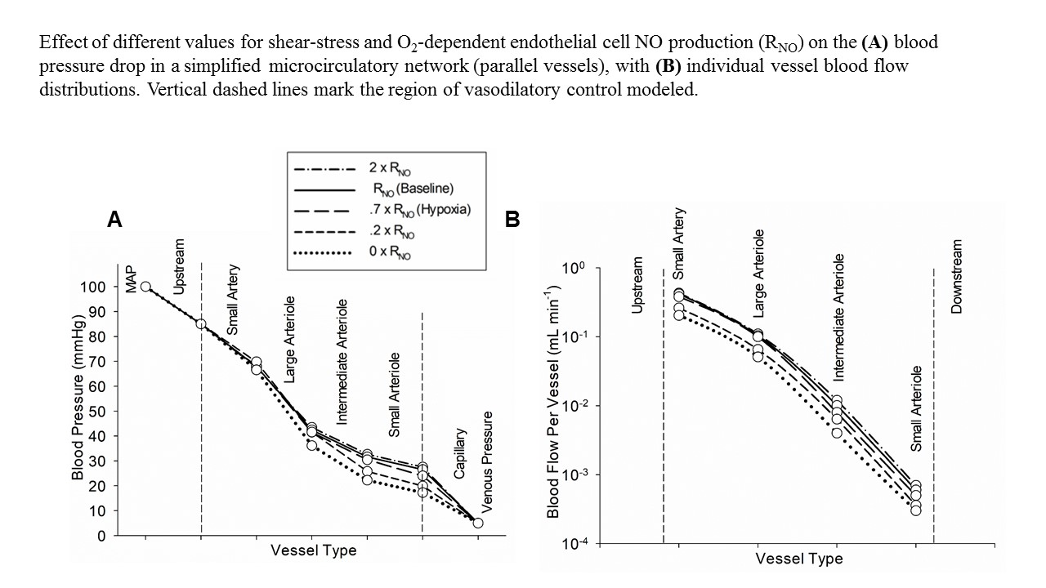

Note that the complete absence of NO (dotted lines, zero NO production) predicts the lowest blood pressure at the capillaries, resulting in the lowest blood flow.

The dynamic changes in vascular diameter for these 5 conditions are shown below for each vessel category:

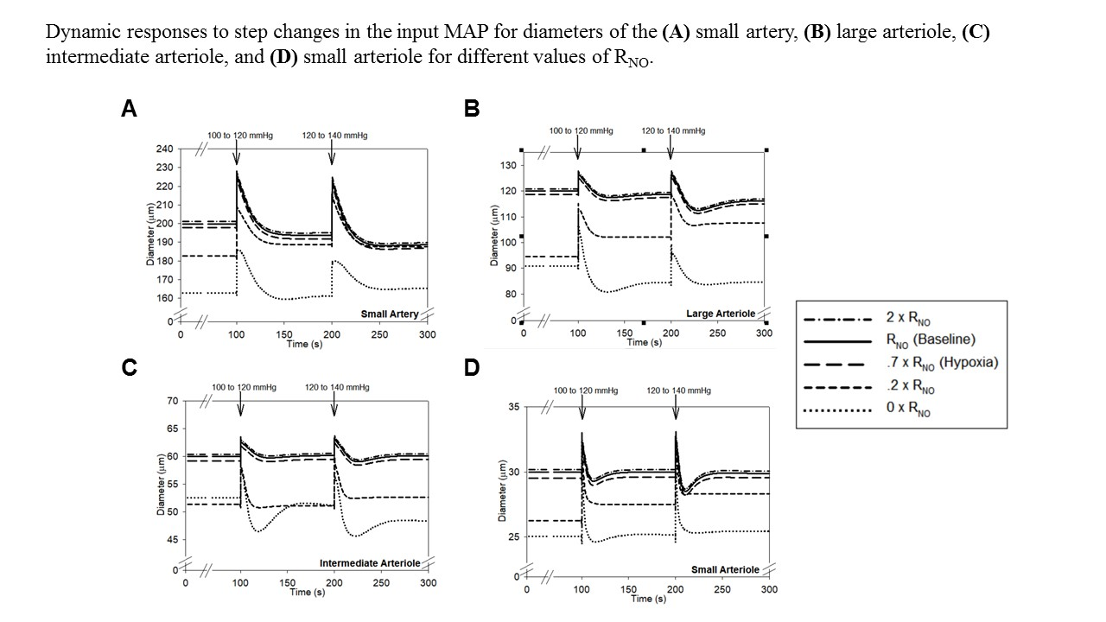

We anticipate that our model predictions will help experimentalists design and interpret their studies of the microcirculation in different organs.

Are you using machine learning and or causal inference methods and how?

*You may insert images by copying and pasting below*

No

Please briefly describe significant MSM achievements made (or expected).

*You may insert images by copying and pasting below*

We are also developing other microcirculatory models, including effects of unequal distributions of hematocrit at vessel bifurcations in a hypothetical microvascular unit that includes 5 branching arterioles that feed 11 capillaries. We evaluated 2 different models (A – Pries and Secomb, 2005; B – Gould and Linninger, 2015) that have been proposed in the literature, and found a significant difference between the models which affects downstream values of vascular smooth muscle NO in different branches, as well as differences in O2 delivery. The average differences in hematocrit and wall shear stress in each vessel in the network predicted for the 2 models are shown below: We are also developing a cellular model to predict effects of spatial colocalization of endothelial nitric oxide synthase (eNOS) with capacitative calcium channels in the endothelial cell membrane on RNO. The model predicts that heterogeneity of eNOS can produce microdomains in the cell membrane with significantly higher calcium concentrations that elevate RNO. Simulation results are shown below for the effects of increasing numbers of microdomains on the average calcium concentration: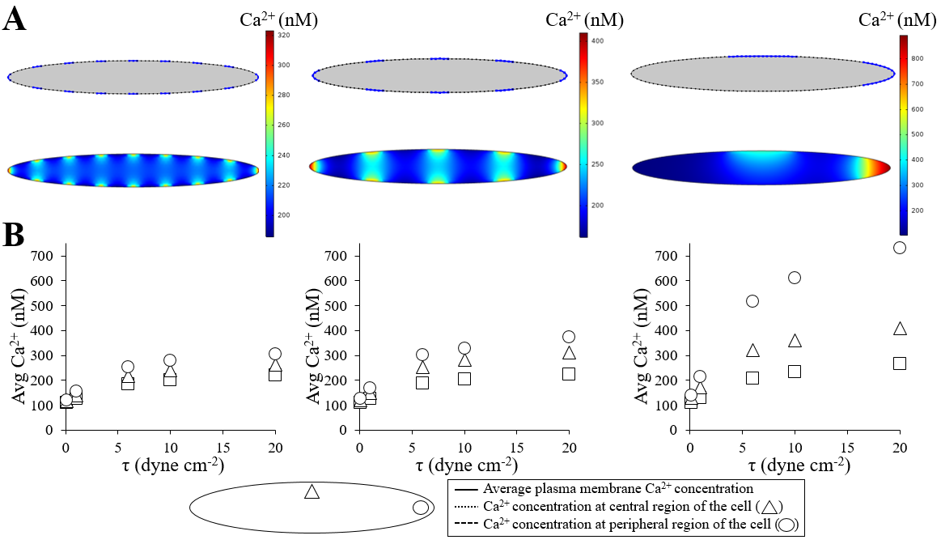

Please suggest any new MSM challenges that should be addressed by the MSM Consortium moving forward.

*You may insert images by copying and pasting below*

There is a paucity of geometric information from which realistic microcirculatory networks can be constructed, as well as limited physiological data for heterogeneity of NO and pO2 in different organs. Our present computational methods using COMSOL software would not be sufficient to solve complex mass transport interactions in a network with heterogenous properties.

What expertise are on your team (e.g. engineering, math, statistics, computer science, clinical, industry) and who?

*Please list as “Expertise – Name, email”*

*Physiology, modeling: Donald G. Buerk, dgb28@drexel.edu; Endothelial cell biology, calcium dynamics: Kenneth A. Barbee, kab33@drexel.edu*

*\*Save your abstract as “MSM PI Last Name _ 2018 IMAG Futures Pre-Meeting Abstract”*

Click [here](mailto:NIBIBimag@mail.nih.gov) to email your form to the NIBIB IMAG mailbox