2018 IMAG Futures Meeting – Moving Forward with the MSM Consortium (March 21-22, 2018)
Pre-Meeting Abstract Submission Form
*Please submit to the NIBIB IMAG mailbox (NIBIBimag@mail.nih.gov) by January 8th, 2018

PI(s) of MSM U01: George Em Karniadakis
Institution(s): Brown University
MSM U01 Grant Number: U01HL114476
Title of Grant: Multiscale modeling of sickle cell anemia: methods and validation

Abstract

Which MSM challenges are you addressing from the IMAG 2009 Report and how?
https://www.imagwiki.nibib.nih.gov/content/2009-imag-futures-report-challenges
(indicate which challenge (#) you’re addressing)
- Novel methods to fuse biological and/or behavioral processes and mechanisms to model outcomes as a result of various interventions
In sickle cell anemia (SCA), the pathogenesis of vaso-occlusion involves several processes across multiple time and length scales, from the nucleation and polymerization of sickle cell hemoglobin to sickling of red blood cells (RBCs), to vaso-occlusion and pain crises in SCA. We have developed a multiscale approach that can handle the disparity of molecular, mesoscopic and macroscopic scales simultaneously, leading to a unique predictive patient-specific model to simulate the evolution of a sickling crisis, which accounts for homogeneous and heterogeneous nucleation, growth of sickle hemoglobin fibers, cell sickling, blood flow alteration, and the entrapment of sickle RBCs in capillaries and venules.
- Problem-driven multiscale models that require high performance computing
The number of degrees of freedom (DOF) in the proposed simulations is O(100M) and hence the time-continuous two-way coupling methodology we proposed should be parallelizable and scalable to tens of thousands of processors. Correspondingly, we address the heterogeneity in computational complexity, the volume of data transfer across scales, load balancing, parallel I/O, data processing, multiscale visualization, etc. We have extended a parallel framework we have developed for interfacing atomistic-continuum formulations.
- Model predictions that drive a community of experimentalists towards systematic testing and validation
We have developed a unique predictive patient-specific model of SCA to quantify the collective dynamics and rheology of blood flow in SCA. Our computational results suggest that treatment with hydroxyurea (on-HU) improves or worsens the rheological characteristics of blood in SCA depending on the degree of hypoxia. Such model predictions drive the experimentalists, including Dr. Ming Dao’s group at MIT, towards systematic testing and validation. Also, the heterogeneous nature of RBCs in SCA results in special challenges for developing predictive models. To make model predictions more reliable, it would require further mesoscopic validation and reliability testing of these models against experimental and clinical studies.

Are you using machine learning and or causal inference methods and how?
Yes. Using a machine-learning tool known as a deep convolutional neural network (CNN), we have developed a new computational framework to classify the shapes of red blood cells (RBCs) in a patient's blood. The new framework uses three steps to classify the shapes of RBCs in microscopic images of blood. First, it distinguishes RBCs from the background of each image and from each other. Then, for each cell detected, it zooms in or out until all cell images are a uniform size. Finally, it uses deep CNNs to categorize the cells by shape to eight different categories.

Please briefly describe significant MSM achievements made (or expected).
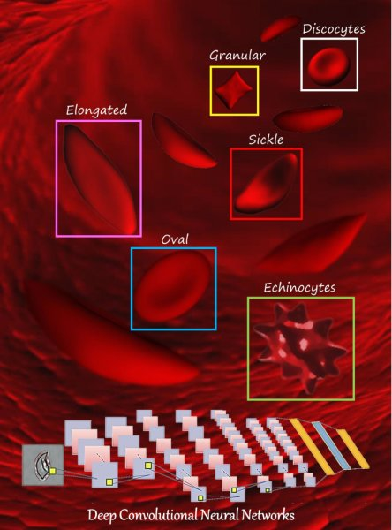
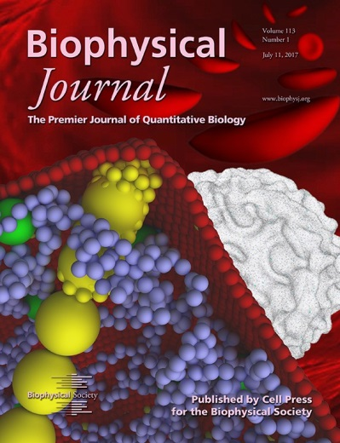
Sickle cell anemia (SCA) is an inherited blood disorder exhibiting heterogeneous morphology and abnormal dynamics and rheology. We combine microfluidic experiments with multiscale simulations to study the mechanics, rheology, polymerization, and adhesive dynamic of patient-specific SCA blood. Specifically, at the vessel scale, using computer models, we have discovered it is a sticky type of red blood cells (RBCs) that starts the blockage and leads to a sickle cell crises. This is the first study to identify a specific biophysical mechanism through which vaso-occlusion takes place. At the cellular scale, we characterized the complex behavior of individual sickle RBCs in a capillary-like microenvironment under transient hypoxia through patient-specific predictive computational simulations that were informed by companion microfluidic experiments. At the molecular scale, we have developed a particle-based hybrid hemoglobin model for studying the growth dynamics of polymer fibers; our simulations provide new details on fiber-fiber interactions and how SCA manifests inside RBCs. We also proposed a kinetics model to simulate the evolution of a sickling crisis at the subcellular level, which accounts for homogeneous and heterogeneous nucleation, growth of sickle hemoglobin fibers, and their branching. This new model can predict the cell sickling process with different sickle hemoglobin concentrations at different deoxygenation rates. Another major development is the use of deep learning, specifically deep convolutional neural networks (CNN), for classification of RBCs in SCA.

Please suggest any new MSM challenges that should be addressed by the MSM Consortium moving forward.
- Multi-fidelity modeling via machine learning of multiscale biological systems
- Physics/Biology-informed learning machines for discovering new models

What expertise are on your team (e.g. engineering, math, statistics, computer science, clinical, industry) and who?
Math – George Em Karniadakis, george_karniadakis@brown.edu
Engineering – Ming Dao, mingdao@mit.edu
Engineering – Peter Vekilov, vekilov@uh.edu
Clinical – John M. Higgins, higgins.john@mgh.harvard.edu

