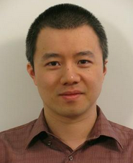
Le Song is an Associate Professor in the Department of Computational Science and Engineering, College of Computing, Georgia Institute of Technology. He received his Ph.D. in Machine Learning from University of Sydney and NICTA in 2008, and then conducted his post-doctoral research in the Department of Machine Learning, Carnegie Mellon University, between 2008 and 2011. Before he joined Georgia Institute of Technology in 2011, he was a research scientist at Google briefly. His principal research direction is machine learning, especially kernel methods and probabilistic graphical models for large scale and complex problems, arising from artificial intelligence, network analysis, computational biology and other interdisciplinary domains. He is the recipient of the Recsys'16 Deep Learning Workshop Best Paper Award, AISTATS'16 Best Student Paper Award, IPDPS'15 Best Paper Award, NSF CAREER Award'14, NIPS'13 Outstanding Paper Award, and ICML'10 Best Paper Award. He has also served as the area chair or senior program committee for many leading machine learning and AI conferences such as ICML, NIPS, AISTATS and AAAI, and the action editor for JMLR.

