2018 IMAG Futures Meeting – Moving Forward with the MSM Consortium (March 21-22, 2018)
Pre-Meeting Abstract Submission Form
*Please submit to the NIBIB IMAG mailbox (NIBIBimag@mail.nih.gov) by January 8th, 2018
*Save your abstract as “MSM PI Last Name _ 2018 IMAG Futures Pre-Meeting Abstract”

PI(s) of MSM U01: Ching-Long Lin
Institution(s): University of Iowa
MSM U01 Grant Number: NIH U01 HL114494
Title of Grant: An integrative statistics-guided image-based multi-scale lung model

Abstract

Which MSM challenges are you addressing from the IMAG 2009 Report and how?
https://www.imagwiki.nibib.nih.gov/content/2009-imag-futures-report-challenges
(indicate which challenge (#) you’re addressing)
You may insert images by copying and pasting below
(The challenges that we have addressed and have been addressing are #3, 4, 8, 9, 11, and 15.)
Accurate prediction of airflow distribution and aerosol transport in the human lungs, which are difficult to be measured in vivo but important to understand the structure and function relationship, is challenging. It is because the interplay between them spans more than two orders of magnitude in dimension from the trachea to alveoli. Our research focuses on developing the techniques and strategies for modeling lungs both within and between subjects, viz. subject-specificity versus generalization from individuals to populations, with both exhibiting multiscale characteristics. For “within subjects” modeling, a computed tomography (CT)-derived subject-specific computational fluid dynamics (CFD) lung model is developed. The model is essential in linking and predicting local structural and functional interactions in individuals. For “between subjects” modeling, machine learning is employed to identify homogeneous sub-populations (clusters), among healthy and diseased populations, aiming to bridge individual and population scales. The three major challenges that we have overcome are inter-subject variability (due to, for example, gender, age and height), inter-site variability (due to scanner and imaging protocol differences), and definition of novel quantitative CT (QCT) imaging-based metrics at multiple scales (due to alterations at different disease stages) needed for machine/deep learning. Use of the cluster membership to guide subject-specific CFD analysis enables an examination of the cluster-specific structural and functional relationships toward precision medicine.

Are you using machine learning and or causal inference methods and how?
You may insert images by copying and pasting below
Yes, we developed a multiscale-imaging based cluster analysis (MICA) for analysis of asthmatic populations (J Allergy Clinical Immunology (JACI) 2017 Sep; 140(3):690-700). We employed an unsupervised machine learning technique (clustering) for grouping sub-populations of patients. Recently we further enhanced MICA for analysis of a chronic obstructive pulmonary disease (COPD) cohort.

Please briefly describe significant MSM achievements made (or expected).
You may insert images by copying and pasting below
The clinical and phenotypic characteristics of asthma vary between patients. Thus categorizing asthma sub-groups may be valuable for guiding subject-specific therapy. With the multicenter imaging data, we performed an imaging-based cluster analysis, and found unique differences in the airways and parenchyma of the patients in these clusters. Four distinct asthmatic phenotypes were derived using MICA (see Figure below taken from our JACI paper). The imaging-based clusters demonstrated differences in clinical characteristics including asthma severity, gender, onset of asthma, pulmonary function, inflammatory biomarkers, as well as responses to asthma questionnaires. The study concludes that the new asthma sub-groups may provide better treatment targets in the future, and a framework to possibly identify subpopulations within other chronic lung diseases. 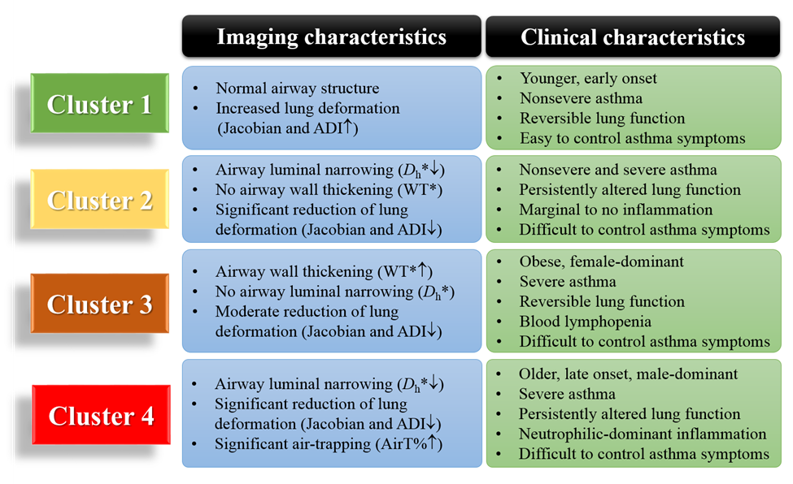
Please suggest any new MSM challenges that should be addressed by the MSM Consortium moving forward.
You may insert images by copying and pasting below
Employment of cutting-edge deep learning techniques and development and validation of predictive models based on longitudinal data.

What expertise are on your team (e.g. engineering, math, statistics, computer science, clinical, industry) and who?
Please list as “Expertise – Name, email”
Engineering – Ching-Long Lin, ching-long-lin@uiowa.edu, Radiology – Eric A. Hoffman, eric-hoffman@uiowa.edu, Bioengineering - Merry Tawhai, m.tawhai@auckland.ac.nz, Physiology and clinical -John Newell, john-newell@uiowa.edu, Statistics – Kung-Sik Chan, kung-sik-chan@uiowa.edu

