Title: Image-based Multi-scale Modeling Framework of the Cardiopulmonary System: Longitudinal Calibration and Assessment of Therapies in Pediatric Pulmonary Hypertension (Figueroa, Baek, Dorfman)
1. Brief Summary
Pulmonary Hypertension (PAH) is a complex disorder associated with elevated pulmonary arterial pressure and pathologies in the pulmonary arteries. Progressive thickening and/or stiffening of distal pulmonary vessels yield to an increase in pulmonary arterial pressure which can lead to fatal right heart failure. The objective of this study is to develop a multiscale model of the cardio-pulmonary system that accounts for both hemodynamics, and tissue Growth and Remodeling (G&R). From a translational perspective, the model will assist with patient stratification based on mechanistic markers (parameters), and will provide a framework on which to virtually test the performance of pharmacological interventions.
In this mid-report, we have taken the following steps to ensure the credibility of our modeling framework.
2. Model Credibility Plan
Rule 1 – Define context clearly
The ultimate goals are clearly defined by the three Specific Aims. Aim 1: Develop a unique MS computational framework of the cardiopulmonary system that couples multi-physics and G&R models of the pulmonary vasculature ad the heart; Aim 2: Calibrate the multiscale framework using longitudinal data prospectively acquired in children with PAH and cardiac transplant controls; and Aim 3: Apply the MS framework to investigate the effect of different pharmacological therapies for PH. Currently, we focus on Aim 1 and 2.
Rule 2 – Use appropriate data
For clinical study the proposed plan will obtain the clinical data (sequential imaging (MRI) and pressure measurements by heart catheterization on cardiopulmonary function) from 25 patients over 4 years (20 with PAH and 5 controls). The obtained clinical data will be utilized for building the MS computational framework (Aim 1), testing calibration of the multiscale framework against the clinical data (Aim 2), and applying the framework for exploring new pharmacological therapies (Aim 3). For the controls, cardiac transplant patient cohort allows obtaining the same type of clinical data (invasive heart catheterization) otherwise not available. During the past 1.5 year, 6 patients were enrolled for this prospective study. The quantities of interest for calibration process at macro- and meso-spatial scales of the model are listed in Table 1. Such data and calibration process are necessary for building an appropriate patient-specific computational simulations.
Calibration Process | Heart | Large Vessels | Microvasculature
Quantity of interest | Cardiac output, contractility, volume | Stiffness, diameter | Resistance
Macroscale parameters | Stiffness | Stiffness, diameter | Resistance, compliance
Mesoscale parameters | Hypertrophy/atrophy rate | Collagen mass production, turnover rate, smooth muscle cells proliferation | Vessel thickness, vessel radius
Measurements | Myocardial strain, PV loop, geometry | Pressure, flow, blood velocity | Resistance

Rule 3 – Evaluate within context
The key goal of model validation is to ensure that our computational modeling framework is a reasonable representation of the cardiopulmonary system comprising the heart, main arteries and the distal vessels i.e., model’s predictions should be consistent with physical observation. As the first step, we have developed a high spatial resolution multi-organ finite element modeling of ventricular-arterial coupling that enables us to take into account bi-directional interactions between the heart and vasculature. To develop insights of ventricular-arterial interactions, the framework was applied to simulate how alterations in the geometrical, material parameters of microstructure of the arterial model in the framework led to changes in the functional behaviors of both LV and vice versa. This modeling framework was described in a recent publication [Shavik et al., 2018], which we show that the prediction of the computational model agrees well with clinical measurements from various references. We are also starting to develop a pipeline to calibrate our ventricular-vascular modeling framework using patient-specific MR images and invasive pressure measurements (Figure 1).
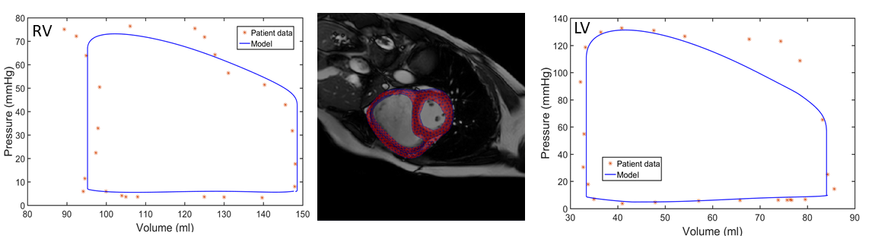Figure 1. Effect of inter-lamellar fibers on radius-pressure and axial force-pressure relations. Symbols: experimental data; lines: model prediction with (solid) and without (dashed) inter-lamellar fibers network. Calibration of patient-specific cardiac model against invasive pressure-volume loop measurements.
We have developed a finite element model of the systemic and pulmonary vasculature utilizing 0D heart models as the inflow boundary conditions (Figure 2). The parameters of the 0D heart models will be determined from the bi-ventricular model. The patient-specific geometry is constructed from MR image data, while the stiffness of the tissue wall is calculated from MR strain measurements and invasive pressure measurements. To improve the agreement between the simulated results and clinical data, we will continue adjusting the heart model and boundary condition parameters until the clinical data is matched.
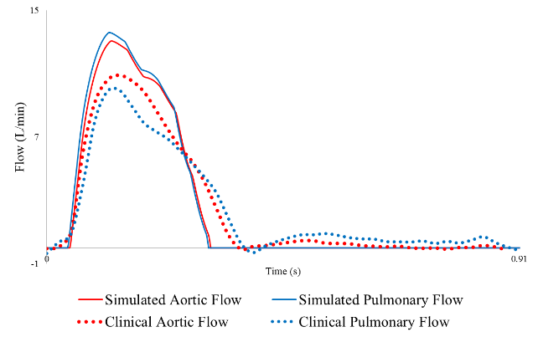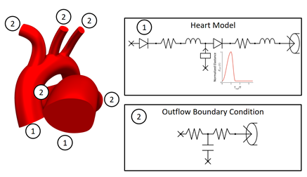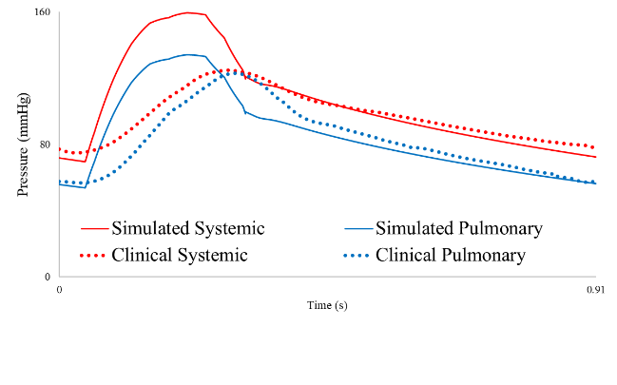
Figure 2. Left: Computational model of vasculature constructed from patient-specific MR image data. The model utilizes a 0D heart model (1) as the inflow boundary condition and 3-element 0D Windkessel models (2) as the outflow boundary conditions. Right: Simulated flow and pressures waveforms at the inlets of the systemic and pulmonary vasculature compared with the clinical data.

For the proposed multi-scale modeling, we employed the Fluid-Solid-Growth (FSG) framework, which combined hemodynamics to G&R, and extended it to the arterial tree model [Filonova et al., 2018]. To this end, we has developed a new temporal multiscale formalism, which was critical for clarifying the model assumptions and appropriate linearization without compromising arterial wall behavior as well as identifying the future modeling extension (e.g., including nonlinearity by higher-order models). The temporal multiscale analysis will be utilized for calibrating the multi-temporal model with the longitudinal clinical data, which fits Aim 2.
Rule 4 – List limitations explicitly
Computational methods for hemodynamics is currently limited to linear membrane model for the vessel walls. The homeostatic optimization for the arterial tree (within the fluid-solid-growth) is valid for intermediate to small sizes of the vessels, moderate regime of blood flow with linear flow inertia force, and constant viscosity. The current challenges include: limited data for distal pulmonary vasculature as they cannot be measured noninvasively; lack of statistically representative model of the pulmonary arterial tree for human subjects (healthy and with PAH); not simultaneously tacking into account of complexity of incorporation the bi-ventricular heart model together with the large pulmonary vessel model and distal vasculature model for implementing simulations of hemodynamics and G&R.
Rule 5 – Use version control
The CRIMSON software will be available as open-source in November 2018 [Arthurs et al., 2018]. The code is shared in ‘Bitbucket’ repository that uses a built-in version control system.
Rule 6 – Document adequately
The CRIMSON software developments will be documented in the publication [Arthurs et al., 2018].
Rule 7 – Disseminate broadly
The tool for computational hemodynamics for patient-specific modeling is disseminated broadly. There are regular workshops on CRIMSON (4 during last three years) opened to large conferences that targets audience providing the comprehensive guidance for current and perspective users. Outcome of the proposed project were reported at multiple conferences and scientific community meetings: IMAG (March 2018); WCB in Dublin (July 2018); WCCM in New York (July 2018).
Rule 8 – Get independent reviews
The intensive collaboration within three research groups and two doctors creates fruitful environment for independent reviewing of the models. There are regular meetings (every other month) between groups of University of Michigan and Michigan State University that fosters progress and intensive discussions.
Rule 9 – Test competing implementations
In modeling G&R of the vasculature, we have verified two different codes (MATLAB and FEniCS) used in the computational framework by benchmarking their results against those obtained from simplified problems (e.g., semi-analytical solution for an axisymmetric vessel). We recognized that a multi-fidelity modeling in developing a multiscale computational modeling framework is important for providing robust coupling with other compartments, reducing computational cost as well as accurately estimating model uncertainty quantification. The multi-fidelity modeling method has been developed by using a CoKriging technique that quantifies uncertainty of different fidelity modeling (element size and types, geometries such as 1, 2, and 3D), which was applied to modeling vascular mechanics. These results were presented at WCB at Dublin, 2018 [Jiang and Baek, 2018].
For fluid-structure-interaction simulations, we verified the Coupled-Momentum Method (CMM) against analytical solutions from the Womersley’s theory of deformable wall used for modeling pulsatile flow. This verification is important for the CMM method because the method has been embedded into CRIMSON software – the main platform for running patient-specific hemodynamics in large pulmonary vessels [Filonova et al., in revision].
Rule 10 – Conform to standards
Our Data Management Plan describes the timeline at which our (experimental and simulation) data and software code will be shared online soon.

3. Issues/Concerns Identified
We have not identified any critical issues in the standard credibility set by the Multiscale Modeling Consortium.

References
Z. Jiang and S. Baek, A credibility plan of vascular growth and remodeling simulation tool, WCB, Dublin, 2018
S.M. Shavik, Z. Jiang, S. Baek, L. C. Lee, High-resolution multi-organ finite element modeling of ventricular-arterial coupling, Frontiers in Physiology, vol. 9, 119, 2018
V. Filonova, C.J. Arthurs, I.E. Vignon-Clementel, C.A. Figueroa, Verification of the Coupled-Momentum Method with Womersley’s Deformable Wall Analytical Solution, (in revision)
C. Arthurs, R. Khlebnikov, M. Marčan, A. Gomez, D. Dillon-Murphy, F. Cuomo, M.S. Vieira, J. Schollenberger, S. Lynch, C. Tossas-Betancourt, K. Iyer, P. Youssefi, A. Noorani, S. Ben Ahmed, F. Nauta, T. van Bakel, J. Mynard, P. Di Achille, V. Filonova, M. Aguirre, N. Nama, N. Xiao, K. Lau, O. Sahni, S. Baek, C.A. Figueroa, CRIMSON: An open-source Software Framework for Cardiovascular Integrated Modelling and Simulation, Comput. Methods Programs Biomed., Submitted, 2018.
V. Filonova, C.A. Figueroa, H. Gharahi, S. Baek, Modeling Hemodynamics and Homeostatic Conditions in a Multiscale Fluid-Solid Growth Model of the Pulmonary Arterial Tree, WCCMXIII, New York, 2018

