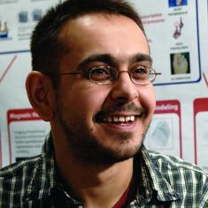 | Ahmet Erdemir, PhD, is the founding director of Computational Biomodeling (CoBi) Core at the Cleveland Clinic, which provides modeling and simulation capacity for simulation-based medicine. Dr. Erdemir also has an ongoing research program in multiscale biomechanics of the musculoskeletal system, from movements of the body to deformations of tissue and cells.  For more details on Dr. Erdemir's research program and translational activities, please refer to http://www.lerner.ccf.org/bme/erdemir/lab.
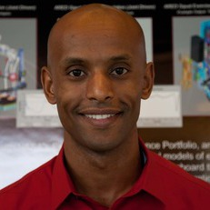 | Lealem Mulugeta is currently Chief Scientist and Executive Director of InSilico Labs LLC. Prior to his venture with InSilico Labs, Lealem worked at NASA as the Project/Lead Scientist of NASA's Digital Astronaut Project (DAP). The DAP is dedicated to implementing well-validated computational models to help predict and assess spaceflight health and performance risks, and to enhance the development of health risk countermeasure. Since joining DAP, Lealem has played a strong role in the development and implementation of standardized methods for verification, validation and credibility assessment of NASA’s biomedical computational models. In doing so, he works very closely with highly multidisciplinary teams of researchers and engineers to develop and implement computational models for space biomedical research.
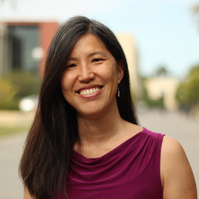 | Joy Ku, PhD, is the Director of Communications and Engagement of the Mobilize Center (http://mobilize.stanford.edu), an NIH Big Data to Knowledge Center of Excellence. She leads their efforts in data sharing and in using wearables within clinical and research applications. She is also the Director of Dissemination and Training for the National Center for Simulation in Rehabilitation Research (http://opensim.stanford.edu). She is a strong advocate of validation and reproducible research. She received her Ph.D. in electrical engineering from Stanford University for her work on in vivo and in vitro validations of finite-element-based simulations of blood flow through comparisons with MRI. And in her current roles, she manages a Web-based project hosting site, called Simtk.org (http://simtk.org), that enables and encourages biocomputational researchers to share data, models, simulation results, and software tools.

