2018 IMAG Futures Meeting – Moving Forward with the MSM Consortium (March 21-22, 2018)
Pre-Meeting Abstract Submission Form
*Please submit to the NIBIB IMAG mailbox (NIBIBimag@mail.nih.gov) by January 8th, 2018
*Save your abstract as “MSM PI Last Name _ 2018 IMAG Futures Pre-Meeting Abstract”

PI(s) of MSM U01: Timothy W. Secomb
Institution(s): University of Arizona, Massachusetts General Hospital
MSM U01 Grant Number: 1U01 HL133362-01A1
Title of Grant: Multiscale modeling of cerebral blood flow and oxygen transport

Abstract

Which MSM challenges are you addressing from the IMAG 2009 Report and how?
https://www.imagwiki.nibib.nih.gov/content/2009-imag-futures-report-challenges
(indicate which challenge (#) you’re addressing)
You may insert images by copying and pasting below
This project aims to develop next-generation multiscale models that integrate different scientific fields, specifically cardiovascular and neuroscience, and predict integrated functions (challenge 1). The computational approach uses high performance GPU-based parallel computing (challenge 8). The work combines experimental and modeling expertise, so that the models will create testable hypotheses leading to new investigational studies (challenges 6 and 9).

Are you using machine learning and or causal inference methods and how?
You may insert images by copying and pasting below
No

Please briefly describe significant MSM achievements made (or expected).
You may insert images by copying and pasting below
Advances in 3D multimodal imaging of microvascular network structure, blood flow and oxygen levels allow us to obtain spatially and temporally resolved data in tissue regions containing thousands of vessel segments. The goal of our project is to gain quantitative understanding of the relationship between neural activation, blood flow and tissue oxygenation in the brain cortex, using multiscale theoretical models for blood flow, oxygen transport and flow regulation in networks of microvessels, together with data from in-vivo microscopic imaging. This requires: (1) image analysis, conversion of 3D intensity maps into connected network structures with information about segment geometry; (2) flow estimation, based on the physics of network flows, limited measurements of individual flow rates in the given network, and empirical information on flow distribution properties; (3) analysis of oxygen transport, including estimation of boundary conditions on inflowing vessels; (4) simulation of flow regulation (neurovascular coupling), and assessing the roles of the mechanisms involved. Significant progress has been made on all these aspects and work is ongoing. Figure shows vascular network containing 3572 segments and 3130 nodes, from mouse cerebral cortex. Overall dimensions of region are 609 × 609 × 662 μm. Cortical surface is at the top. Color coded for segment blood hydrostatic pressures in mmHg.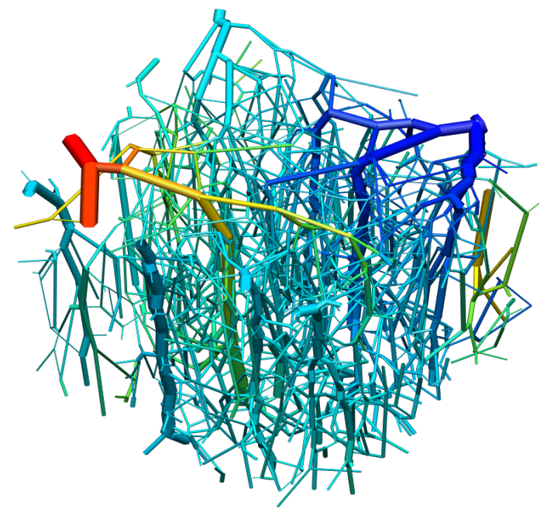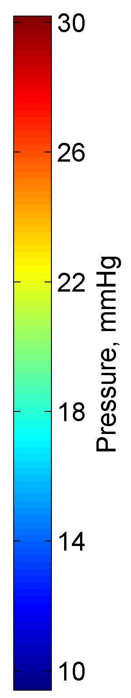

Please suggest any new MSM challenges that should be addressed by the MSM Consortium moving forward.
You may insert images by copying and pasting below
Click or tap here to enter text.

What expertise are on your team (e.g. engineering, math, statistics, computer science, clinical, industry) and who?
Please list as “Expertise – Name, email”
Math modeling, numerical computation - Tim Secomb, secomb@u.arizona.edu. Brain imaging - Sava Sakadzic, sava.sakadzic@mgh.harvard.edu, David Boas, dboas@bu.edu.

*Save your abstract as “MSM PI Last Name _ 2018 IMAG Futures Pre-Meeting Abstract”
Click here to email your form to the NIBIB IMAG mailbox

