2018 IMAG Futures Meeting – Moving Forward with the MSM Consortium (March 21-22, 2018)
Pre-Meeting Abstract Submission Form

PI(s) of MSM U01: Muhammad Zaman and Roger Kamm
Institution(s): Boston University and Massachusetts Institute of Technology
MSM U01 Grant Number: U01 CA177799
Title of Grant: Modeling Bi-Directional Signaling And Cytoskeletal Dynamics In 3D Cell Migrations

Abstract

Which MSM challenges are you addressing from the IMAG 2009 Report and how?
Our proposed research addresses challenges 1 and 9. To this end, we propose a multiscale modeling effort, integrating the fields of mathematics, mechanobiology, and cancer systems biology, and aided by concurrent experimental work, which addresses a significant gap in the current understanding of cancer biology: the effects of the mechanical tumor microenvironment on the pro- or anti-tumorigenic effects of the cytokine transforming growth factor-beta (TGF-β). TGF-β facilitates intercellular communication within tumors, exchanging information between cancer cells, immune cells, and other biological actors including stromal cells and the extracellular matrix. The effects of this cytokine on cancer progression range from tumor suppression to tumor promotion, and the mechanical properties of the tumor microenvironment have been identified as a driving factor in the selection between these outcomes. However, the exact mechanisms underlying this behavior remain unclear. The TGF-β pathway is known to interact with various mechanosensitive signaling actors including the Hippo-YAP/TAZ signaling axis and integrin αvβ6. We propose that these interactions, aided by various mechanical and biochemical feedback loops, facilitate this mechanosensitivity and in large part dictate the downstream effects of TGF-β signaling, which together result in tumor promotion or suppression, as shown in Figure 1. In order to demonstrate and probe this mechanosensitive relationship, we will construct a differential equation model of TGF-β signaling and its interactions with both mechanosensitive signaling pathways and other pathways affected by TGF-β that control processes including cell migration, tumor growth, extracellular matrix remodeling, and metabolism. Informing this model with concurrent experimental work, we will test the hypothesized interactions between these signaling pathways, determine the primary signaling species and network motifs responsible, and explore strategies by which TGF-β signaling may be forced toward a pro- or anti-tumorigenic state. Conducting these analyses in both single- and multi-cellular contexts, we intend to examine these processes both as they affect single cancer cells and as they result in distributed behaviors across the dynamic, heterogeneous, and intercommunicative tumor microenvironment.

Are you using machine learning and or causal inference methods and how?
In the course of this study, we will produce various parameter-rich models, which will require suitable parameter fitting methodologies. To achieve this, we intend to draw from established protocols from machine learning, including backpropagation.

Please briefly describe significant MSM achievements made (or expected).
The multiscale modeling environment we propose will combine elements of systems biology, physics, and molecular cancer biology. Our differential equation modeling framework will consider cell signaling dynamics, spatiotemporal variation in chemical and mechanical tumor contexts, and tumor-scale migratory and proliferative behavior.

Please suggest any new MSM challenges that should be addressed by the MSM Consortium moving forward.
We propose the following new MSM challenges: 1) the integration of immune science into modeling efforts, 2) the integration of biomechanics with cellular systems modeling, and 3) evidence based clinical data integrated into modeling.

What expertise are on your team (e.g. engineering, math, statistics, computer science, clinical, industry) and who?

Cell Mechanics and Migration – Muhammad Zaman, Ph.D., zaman@bu.edu
Cell Mechanobiology – Roger Kamm, Ph.D., rdkamm@mit.edu
Applied Mathematics – Fabian Spill, Ph.D., f.spill@bham.ac.uk
Cancer Biology – Ran Li, Ph.D., rli14@mgh.harvard.edu
Computational Modeling – R.J. Seager, rseager@bu.edu
Cancer Biology – Cynthia Hajal, chajal@mit.edu
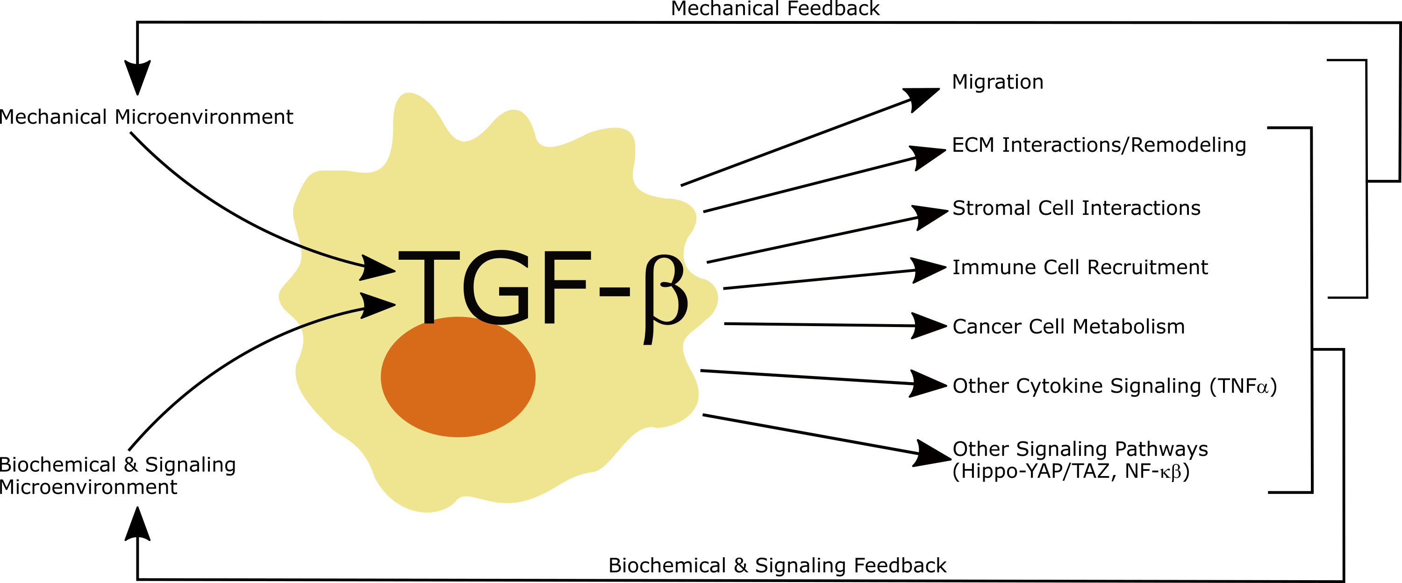

Figure 1. Mechanical regulation of the disparate effects of TGF-β signaling and resulting feedback. In response to TGF-β signaling, a variety of cancer cell behaviors including migration, ECM interactions, stromal and immune cell recruitment, metabolic changes, and interaction with other intracellular and extracellular signaling occur. All of these processes provide some form of feedback, whether mechanical or biochemical, that subsequently modulates TGF-β signaling, creating a feedback loop. Feedback loops are one network motif that enables TGF-β to act as such a powerful regulator, particularly in the multicellular, tumor context. Together, the downstream processes regulated by TGF-β result in either tumor promotion or suppression.

